**Chapter 1: System Introduction**

**Chapter -1**

**Systems Introduction**

* 1. **Brief Description of the System**

Online Technical Fest is used to conduct technical fest events online. Students can register themselves without approaching any intermediate. This helps coordinators and students to save time because of the direct approach being used. It has specific deadlines for each event and the students are required to register themselves before it. They can find the location where the fest will be held. Actors in our system are Admin and Students. Information about the events is provided manually by the faculty to the coordinators. Student details are discarded after the completion of the events.

* 1. **About The Proposed System**

**Aim, Objective & Scope.**

Online Technical Fest aims at conducting and managing fest events online to reduce the efforts and make the process faster. This helps to inform about the events and their details to a huge number of viewers. This helps the students to register themselves anywhere and anytime.

This system has a wide scope since we are organizing these events online. It has specific deadlines for each event and the students are required to register themselves before it.

* 1. **Methodologies used for Analysis, Design & Development**

**SDLC Model**

SDLC Stands for Software Development Lifecycle Model. **Software Development Life Cycle**, or Software Development Process, defines the steps/ stages/ phases in the building of software. The development models are the various processes or methodologies that are being selected for the development of the project depending on the project’s aims and goals. There are many development life cycle models that have been developed in order to achieve different required objectives. The models specify the various stages of the process and the order in which they are carried out. The selection of model has very high impact on the testing that is carried out. It will define the what, where and when of our planned testing, influence regression testing and largely determines which test techniques to use. The Model that we prefer for our project is Iterative Waterfall Model.

**Stages of Model**

1. **Requirement analysis and specification phase:**

The goal of this phase is to understand the exact requirement of the customer and to document them properly. The requirement describes the “what” of a system not the “how”. This phase produce a large document written in a natural language, contains a description of what a system will do without describing how it will be done.

1. **Design:**

The goal of this phase is to transform the requirements specification into a structure that is suitable for implementation in some programming language. Here, overall software architecture is defined, and the high level and detailed designed work is performed. This work is documented and known as software design description (SDD) document**.**

1. **Implementation and unit testing phase:**

During this phase design is implemented. If the SDD is complete, the implementation and coding phase proceeds smoothly, because all the information needed by the software developers is contained in SDD.

1. **Integration and system testing phase:**

This is very important phase the purpose of unit testing is to determine that each independent module correctly implemented, to determine that the interface between modules is also correct, and for this reason integration testing is performed. System testing involves the testing of the entire system, whereas software is a part of system.

1. **Operation and maintenance phase:**

Software maintenance is a task that every development group has to face. When the software is delivered to the customer site, install and is operational. Therefore the release of the software inaugurates the operations and maintenance phase of the lifecycle.

**Block Diagram of Iterative Waterfall Model**

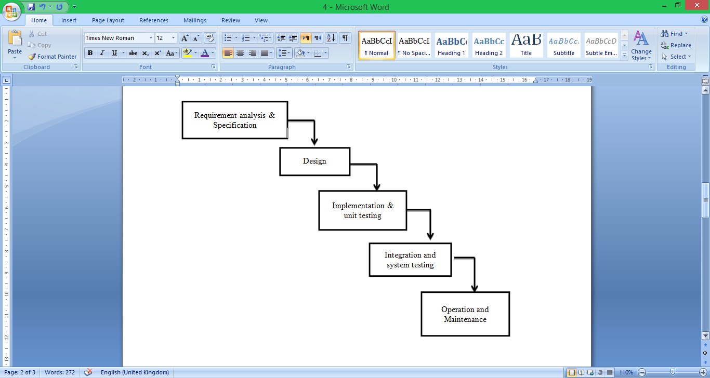

Figure 1.1: Iterative Waterfall Model

**Reasons for choosing Model**

1. This model is simple and easy to understand and use.
2. Users are actively involved in the development.
3. Errors can be detected much earlier.
4. Quicker user feedback is available leading to better solutions.
5. Missing functionality can be identified easily.
6. Confusing or difficult functions can be identified.
7. In this model phases are processed and completed one at a time. Phases do not overlap.
8. It works well for smaller projects where requirements are very well understood.

* 1. **Methodologies for Data Collection**

Data Collection can be defined as the process of collecting information. There are two types of data:

1. **Primary data Collection**

Primary data means original data that has been collected for the purpose in mind. It means that the data that has been collected from first-hand experience is known as primary data.

**Source of primary data for our project:**

* With the help of questionnaires

1. **Secondary Data Collection**

Secondary Data Collection is that data which has been already collected by and readily available from other sources in any form. The secondary data are cheaper and more quickly obtainable than primary data.

**Sources of secondary data for our project**

**Web search**: www.Google.co.in,Wikipedia.org

**References**: Software Engineering (K. K. Aggarwal), DBMS (Nawathe)

* 1. **Project Planning**

**Gantt chart**:

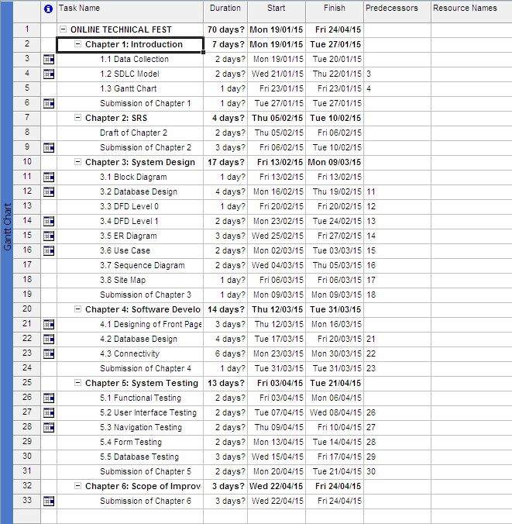

Figure 1.2: Gantt Chart Data

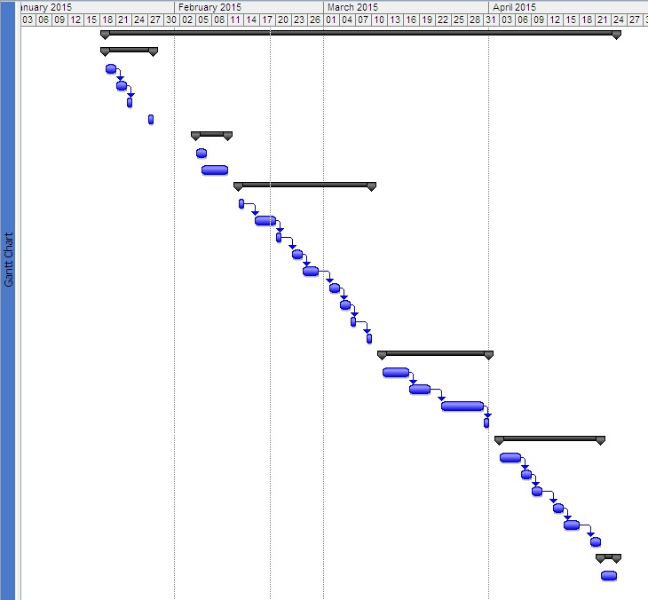

Figure 1.3: Gantt Chart Data

**Chapter 2: System Requirement Specifications**

**Chapter – 2**

**Software Requirement Specifications**

**Introduction**

The following subsections of Software Requirement Specifications Document should facilitate in providing the entire overview of the Information system “Online Technical Fest” under development. This document aims at defining the overall software requirements for your end users. Efforts have been made to define the requirements of the Information system exhaustively and accurately.

**Purpose**

The main purpose of Software Requirement Specifications Document is to describe in a precise manner all the capabilities that will be provided by the Software Application “Online Technical Fest”. It also states the various constraints which the system will be abide to. This document further leads to clear vision of the software requirements, specifications and capabilities. These are to be exposed to the development, testing team and end users of the software.

* + 1. **Scope**

This system has a wide scope since we are organizing these events online. It has specific deadlines for each event and the students are required to register themselves before it.

* + 1. **Definition, acronyms, abbreviations**

**DFD: -** Data Flow Diagram.

**ER Diagram: -** Entity Relationship Diagram.

**Admin: -** Administrator.

* + 1. **References**

1. <http://en.wikipedia.org/>
2. <http://www.google.com/>
   * 1. **Overview**

This document has been prepared in accordance with the IEEE standard 30/1998, IEEE recommended practice for software requirement specification. It provides the information of product perspective, product function, user characteristics, constraints, assumptions and dependencies and specific requirements.

The rest of this SRS document describes the various system requirements, interfaces, features and functionality in detail.

* 1. **Overall description of proposed system**
     1. **Product Perspective**

The application will be windows-based, self-contained and independent software product.

HTML,

PHP

MySQL Server

Figure 2.1

* + - 1. **System Interfaces**

The system will be complete window based operating system with configuration as:

**OS**: XP/VISTA/7/8

**Processor**: Intel Core 2 duo, Dual Core etc.

* + - 1. **Interfaces**

The application will have a user friendly and menu based interface. Following screens will be provided.

1. A **Login/Registration Screen** for entering username, password and role (Administrator, User) will be provided. Access to different screens will be based upon the role of the user. The Login Screen for the user and administrator should be different .So the user can’t interfere in working of administrator.
2. The **Modification Screen** will be provided to the DBA. If the admin wants to make any modification in details of the spiritual places whether it is updating or deletion or modification, the DBA can do this with the help of Modification screen.
   * + 1. **Hardware Interfaces**

**Processor :** Pentium 4 or higher

**Processor Speed** **:** 1.7 GHZ (min.)

**RAM**  **:** 512 MB or more

**Hard Disk Space** **:** 8 GB (min.)

**Operating System** **:** Windows 2000/XP/VISTA/7/8

**Monitor** **:** VGA/SVGA

**Mouse :** 2/3 Buttons

**Keyboard :** 104/84 Keys

* + - 1. **Software Interfaces**

**Operating System** : Windows 2000/ XP/VISTA/7/8/

**Front end** : HTML, PHP

**Back end** : MySQL

* + - 1. **Communication Interfaces**

The System shall use the HTTP protocol for communication over the internet and for the intranet communication will be through TCP/IP protocol suite.

* + - 1. **Memory Constraints**

**RAM** : 512 MB or more

**Hard disk** : 20 GB or more

* + - 1. **Operations**

This product will not cover any automated housekeeping aspects of database. The DBA at client site will be manually deleting old/ non required data. Database backup and recovery will also have to be handled by DBA.

* + - 1. **Site Adaptation Requirement**

The terminals at client side will have to support the hardware and software interfaces specified.

* + 1. **Product functions**

The system will allow access only to authorized users with specific roles (Administrator, Operator). Depending upon the user’s role, he/she will be able to access only specific modules of the system.

A summary of the major functions that the software will perform:

1. **A Login facility for enabling only authorized access to the system**: Access control is the selective restriction of access to a place or other resource. The act of accessing may mean consuming, entering, or using. Permission to access a resource is called authorization. Locks and login credentials are two analogous mechanisms of access control
2. **Users (with role operator) will add/update/delete the stored information and so on:** In computer programming, create; read, update and delete (CRUD) (Sometimes called SCRUD with an "S" for Search) are the four basic functions of persistent storage. Sometimes CRUD is expanded with the words retrieve instead of read, modify instead of update, or destroy instead of delete. It is also sometimes used to describe user interface conventions that facilitate viewing, searching, and changing information; often using computer-based forms and reports. The term was likely first popularized by James Martin in his 1983 book managing the Data-base Environment. The acronym may be extended to CRUDL to cover listing of large data sets which bring additional complexity such as pagination when the data sets are too large to hold easily in memory. CRUD is also relevant at the user interface level of most applications. For example, in address book software, the basic storage unit is an individual contact entry. As a bare minimum, the software must allow the user to:

1. Create or add new entries

2. Read, retrieve, search, or view existing entries

3. Update or edit existing entries

4. Delete/deactivate existing entries

Without at least these four operations, the software cannot be considered complete. Because these operations are so fundamental, they are often documented and described under one comprehensive heading, such as "contact management", "content management" or "contact maintenance" (or "document management" in general, depending on the basic storage unit for the particular application).

* + 1. **User Characteristics**

1. **Educational Level**: At least graduate and should be comfortable with English language.
2. **Technical Expertise:** Should be a high or middle level employee of the organization comfortable with using general purpose applications on a computer.
   * 1. **Constraints**

None

* + 1. **Assumptions and Dependencies**

**Assumptions:** The code should be free with all possible errors and the product must have an interface which is simple enough to understand.

**Dependencies:** All necessary hardware and software are available for implementing and use of the tool. The proposed system would be designed, developed and implemented based on the software requirements specifications document. Users should have basic knowledge of computer and we also assure that the users will be given software training documentation and reference material.

* + 1. **Apportioning Requirement**

Not Required

* + 1. **Specific Requirements**

This section contains the software requirements to a level of detail sufficient to enable designers to design the system, and testers to test the system.

* + 1. **External Interfaces**
    2. **User Interfaces**

Refer 2.1.2

* + 1. **Hardware Interfaces**

Refer 2.1.3

* + 1. **Software Interfaces**

Refer 2.1.4

* + 1. **Communication Interfaces**

None

* + 1. **Specific requirements** 
       1. **Classes for classification of specific requirements**

Not Applicable

* + 1. **Performance requirements**

None

* + 1. **Design constraints**

1. The system runs under Windows XP and Windows latest versions.
2. The system requires regular yearly updating.
   * 1. **Software system attributes** 
        + **Reliability**

This application is a reliable product that produces fast and verified output of all its processes.

* + - * **Availability**

This application will be available to use for your end users and help them to carry out their operations conveniently.

* + - * **Security**

The application will be password protected. User will have to enter correct username, password and role in order to access the application.

* + - * **Maintainability**

The application will be designed in a maintainable manner. It will be easy to incorporate new requirements in the individual modules.

* + 1. **Other requirements**

None

**Chapter 3: System Design**

**Chapter – 3**

**System Design**

* 1. **Physical Design**

Physical design of Spiritual search engine will provide all the mandatory functions which should be beneficial for the organization. In this, we completed the technical blueprints for the system, based on the implementation platform. Physical design is the generation of tables, indexes, defaults and the checking of restraints.

* 1. **Block Diagram**

Block diagram is a diagram of a system, in which the principal parts or functions are represented by blocks connected by lines that show the relationships of the blocks.  They are heavily used in the engineering world in hardware design, electronic design, software design, and process flow diagrams.

The block diagram is typically used for a higher level, less detailed description aimed more understanding the overall concepts and less at understanding the details of implementation.

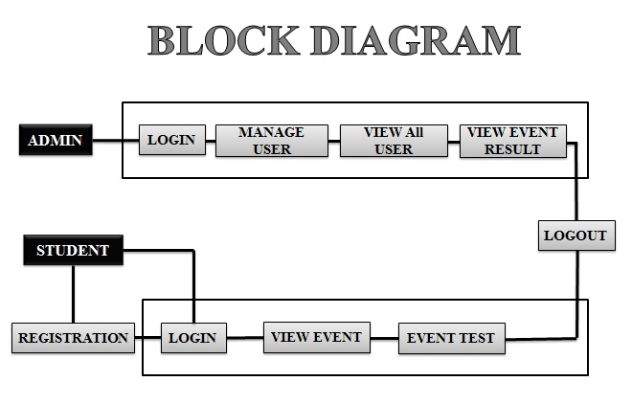

Figure 3.1

* 1. **Use Case**

USE-CASE diagrams are the pictorial representation of entities and their functions. There are two components of a use-case diagram – actors and use cases. It represents what happens when an actor interacts with a system. Hence, a use case diagram captures the functional aspects of a system. The system is shown as a rectangle with the name of the system (or subsystems) inside, the actors are shown as stick figures (even the non-human ones), the use cases are shown as solid bordered ovals labeled with the name of the use case, and relationships are lines or arrows between actors and use cases and/or between the use cases themselves. These components are given below:

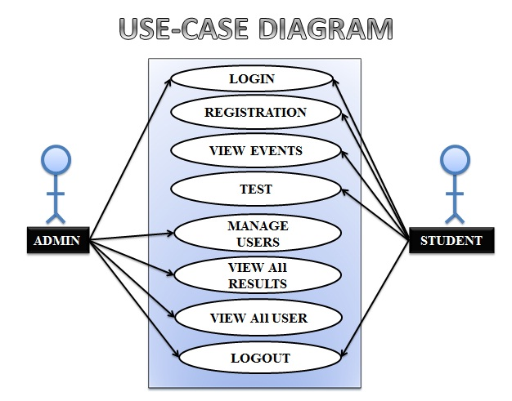

Figure 3.2

* 1. **DFD**

A DFD is a graphical representation that depicts information flow and the transforms that are applied as data moves from input to output. The basic form of a DFD is also known as a Data Flow graph or a Bubble Chart. DFD may be used to represent a system or software at any level of the transaction process. DFD’s can be partitioned into levels that represent increasing information flow and functional details.

**1). Level 0**

The next stage is to create the Level 1 Data Flow Diagram. This highlights the main functions carried out by the system. As a rule, we try to describe the system using between two and seven functions - two being a simple system and seven being a complicated system. This enables us to keep the model manageable on screen or paper.

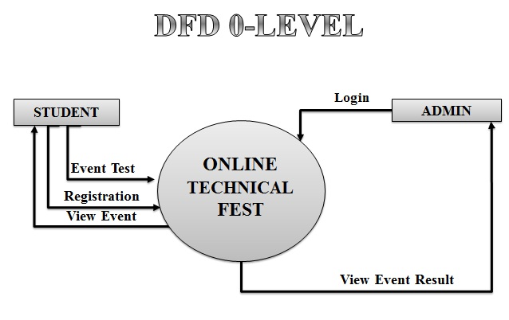

Figure 3.3

**2). Level 1**

Level Two DFD shows a detailed working of each module that is shown in the Level One DFD. These are as follows:

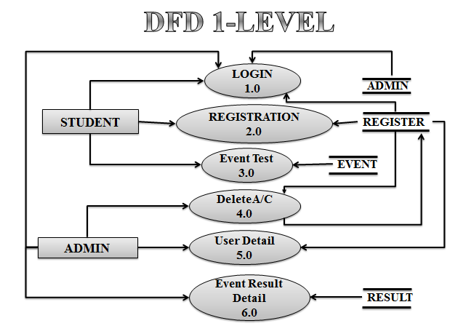

Figure 3.4

* 1. **ER Diagram**

An ER diagram depicts the relationship between data objects. The object-relationship pair can be represented graphically using the Entity-Relationship Diagram. A set of primary components is identified for the ER Diagram: Data Objects, attributes, relationships and various type of indicators. The primary purpose of an ER Diagram is to represent data objects and their relationships.

**Data Objects, Attributes and Relationships**

**Data Objects:** A data object is a representation of almost any composite information that must be understood by software. By composite information we mean something that has a number of different properties or attributes.

**Attributes:**They define the properties of a data object and take on one of the three different characteristics. They can be used to name an instance of the data object, describe the instances or make reference to another instance in another table.

**Relationship:** Data objects are connected to one another in a variety of different ways. We can define a set of objects-relationships pairs that define the relevant relationship. Object-relationship pairs are bi-directional. Different data objects and their attributes are described in the data dictionary and the relationship between these data objects are given in the ER diagram in the next section.

**Cardinality:**The data model must be capable of representing the number of occurrences of objects in a given relationship. The cardinalities of an object-relationship are:

**1). One to One (1:1)** – an occurrence of object ‘A’ can relate to one and only on occurrence of object ‘B’ and the occurrence of ‘B’ can relate to only one occurrence of ‘A’.

**2). One to Many (1:N)** – one occurrence of object ‘A’ can relate to one or many occurrences of object ‘B’ but an occurrence of ‘B’ can relate to only one occurrence of ‘B’.

**3). Many to Many (M:N)** – an occurrence of object ‘A’ can relate to one or more occurrences of ‘B’ while an occurrence of ‘B’ can relate to one or more occurrence of ‘A’.

Cardinality defines “the maximum number of object-relationships that can participate in a relationship”.

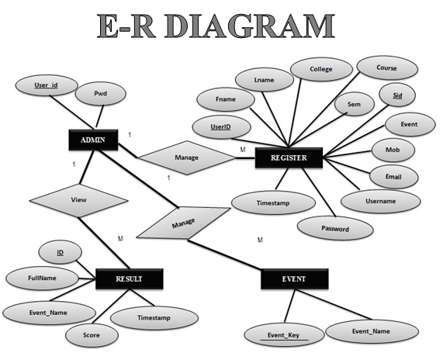Figure 3.5

* 1. **Site Map**

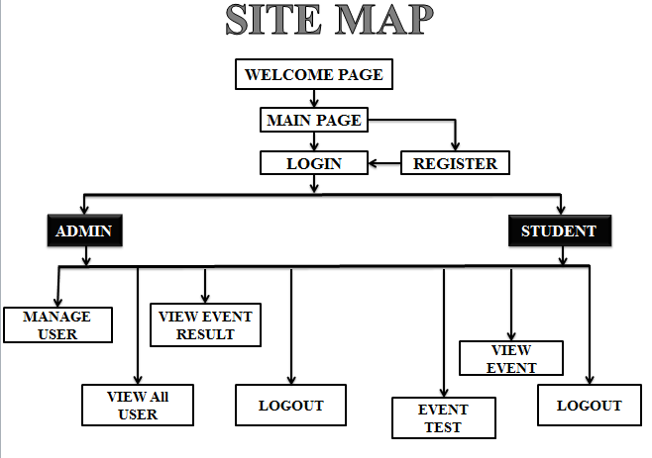

Figure 3.6

* 1. **Sequence Diagram**

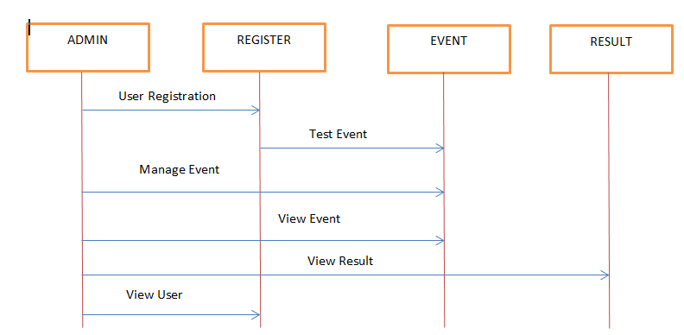

Figure 3.7

* 1. **Database Design**

The information system of “Human Resource Management” performs its function with the help of the data store in certain repositories called Databases of the system. Detailed descriptions of the various databases included in the information systems are tabulated as follows:

1. **Admin:**

|  |  |  |  |  |  |
| --- | --- | --- | --- | --- | --- |
| **S.NO.** | **Field Name** | **Field Type** | **Field Size** | **Constraint** | **Description** |
| **1.** | UserId | Varchar | 20 | Primary | Enter Userid |
| **2.** | Password | Varchar | 20 | - | Enter Password |

Table 3.1: Admin Information

1. **Register:**

|  |  |  |  |  |  |
| --- | --- | --- | --- | --- | --- |
| **S.NO.** | **Field Name** | **Field Type** | **Field Size** | **Constraint** | **Description** |
| **1.** | Fname | Varchar | 20 | - | Enter Student First Name. |
| **2.** | Lname | Varchar | 20 | - | Enter Student Last Name. |
| **3.** | College | Varchar | 20 | - | Enter College Name |
| **4.** | Course | Varchar | 20 | - | Enter Course. |
| **5.** | Sem | Varchar | 20 | - | Enter Semester. |
| **6.** | Sid | Number | 20 | Primary | Enter Student ID. |
| **7.** | Event | Varchar | 20 | - | Select Event |
| **8.** | Mob | Varchar | 10 | - | Enter The Mobile No. |
| **9.** | Email | Varchar | 50 | - | Enter Email ID |
| **10.** | Username | Varchar | 20 | - | Enter Username |
| **11.** | Password | Varchar | 20 | - | Enter Password |

Table 3.2: Student Information

1. **Event:**

|  |  |  |  |  |  |
| --- | --- | --- | --- | --- | --- |
| **S.NO.** | **Field Name** | **Field Type** | **Field Size** | **Constraint** | **Description** |
| **1.** | Event_Key | Number | 20 | Primary | Enter Event Key. |
| **2.** | Event_Name | Varchar | 11 | - | Enter Event Name. |

Table 3.3: Event Information

1. **Result:**

|  |  |  |  |  |  |
| --- | --- | --- | --- | --- | --- |
| **S.NO.** | **Field Name** | **Field Type** | **Field Size** | **Constraint** | **Description** |
| **1.** | ID | Number | 20 | Primary | Enter Id. |
| **2.** | Full Name | Varchar | 20 | - | Enter The Date. |
| **3.** | Event_Name | Varchar | 20 | - | Enter Event Name. |
| **4.** | Score | Number | 20 | - | Enter Score. |
| **5.** | Time | Date | 20 | - | Enter Date &Time. |

Table 3.4: Result Information

**Chapter 4: System development and**

**Implementation**

* 1. **Index.html**

<!DOCTYPE html PUBLIC "-//W3C//DTD HTML 4.01 Transitional//EN" "http://www.w3.org/TR/html4/loose.dtd">

<html width="100%" height ="100%">

<head>

<link rel="stylesheet" type="text/css" href="CSS/Html.css" />

<link rel="stylesheet" type="text/css" href="CSS/HtmlMenu.css" />

<link rel="stylesheet" type="text/css" href="CSS/FooterMenu.css" />

<meta http-equiv="Content-Type" content="text/html; charset=iso-8859-1" />

<title>Main</title>

</head>

<body>

<div id="Holder"><a href = "index.html"><img src="IMG/Logo1.png" align="left" width="287" height="100"/></a><a href = "http://iitmjp.ac.in/"><img src="IMG/Logo2.png" width="140" height="111" align="right"/></a>

<b id="name_ban"><center> REVOLUTION 2K15</center></b></br></br><hr/>

<div><b id="enter">CLICK TO ACCESS......!!!!!</b></div>

<img id="fin" src="IMG/fin.png" width="44" height="56">

<div><center><a href="Home.html"><img id="arc" src="IMG/arc.png" /></a> </center></div>

<div id="fb-root"></div>

<script>(function(d, s, id) {

var js, fjs = d.getElementsByTagName(s)[0];

if (d.getElementById(id)) return;

js = d.createElement(s); js.id = id;

js.src = "//connect.facebook.net/en_US/sdk.js#xfbml=1&version=v2.0";

fjs.parentNode.insertBefore(js, fjs);

}(document, 'script', 'facebook-jssdk'));</script>

<div id = "likebutton" ><div class="fb-like" data-href="https://www.facebook.com/pages/C-programmers/441320139247205" data-width="20" data-layout="box_count" data-action="like" data-show-faces="true" data-share="true"></div></div>

<br><br>

<br><br><br><br><br><br><br><br><br><br><br><br><br><br><br><br><br><br><br><br><br><br>

<div><b id = "visit">Total Visitors No. : <!-- hitwebcounter Code START -->

<a href="http://www.hitwebcounter.com/">

<img src="http://hitwebcounter.com/counter/counter.php?page=5976016&style=0009&nbdigits=5&type=page&initCount=539" border="0" align ="right"></a>

<!- hitwebcounter.com -><a href="http://www.hitwebcounter.com/" style="font-family: Arial, Helvetica, sans-serif;font-size: 9px; color: #6D5B77; text-decoration: underline ;">

</a></b></div>

<b id = "Rec">Recommended :Use Google Chrome<sup>*</sup></b>

<hr/>

</div>

</body>

</html>

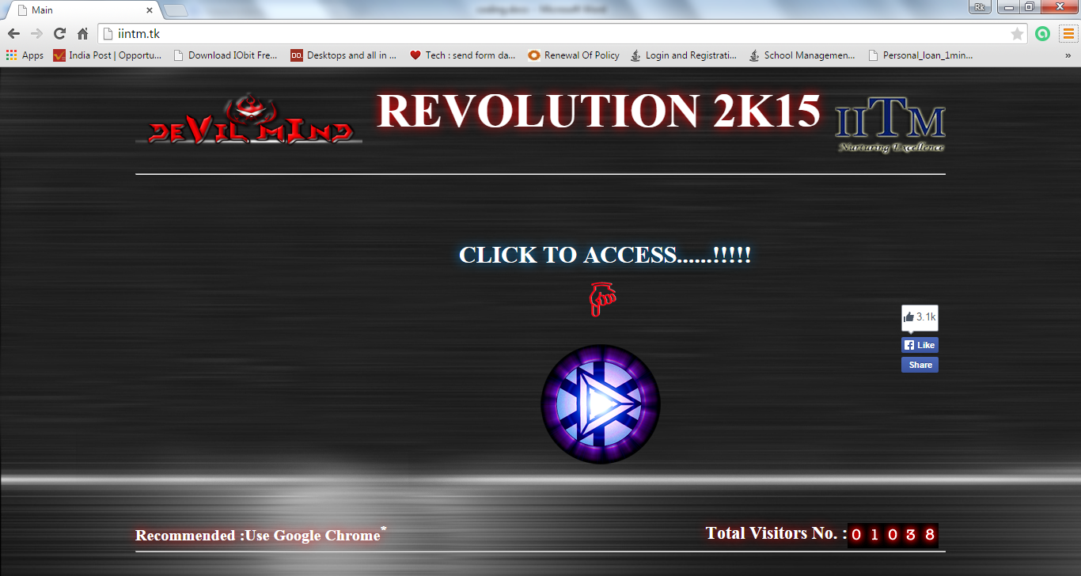

**Screenshot 4.1: Main Page**

* 1. **Home.html**

<!DOCTYPE html PUBLIC "-//W3C//DTD HTML 4.01 Transitional//EN" "http://www.w3.org/TR/html4/loose.dtd">

<html width="100%" height ="100%">

<head>

<script src="JS/Open.js"> </script>

<link rel="stylesheet" type="text/css" href="CSS/Html.css" />

<link rel="stylesheet" type="text/css" href="CSS/HtmlMenu.css" />

<link rel="stylesheet" type="text/css" href="CSS/FooterMenu.css" />

<meta http-equiv="Content-Type" content="text/html; charset=iso-8859-1" />

<title>Home</title>

</head>

<body>

<div id="Holder"><a href = "index.html"><img src="IMG/Logo1.png" align="left" width="287" height="100"/></a><a href = "http://iitmjp.ac.in/"><img src="IMG/Logo2.png" width="140" height="111" align="right"/></a>

<b id="name_ban"><center> REVOLUTION 2K15</center></b></br></br><hr/>

<div id="NavBar"><nav><ul>

<li><img src="IMG/Home.png" width="40" height="40"/><a href="index.html"style="text-decoration:none; color:inherit;">HOME</a></li>

<li><img src="IMG/event.jpg" width="40" height="40"/><a href="Event.html"style="text-decoration:none; color:inherit;">EVENTS</a></li>

<li><img src="IMG/gallery.png" width="40" height="40"/><a href="Gallary.html"style="text-decoration:none; color:inherit;">GALLERY</a></li>

<li><img src="IMG/registration.png" width="40" height="40"/><a href="javascript:Register()" style="text-decoration:none; color:inherit;">REGISTRATION</a></li>

<li><img src="IMG/login.png" width="40" height="40"/><a href="javascript:Login()" style="text-decoration:none; color:inherit;">LOGIN</a></li></ul>

</nav></div><hr/>

<a href="Event.html"><img src="IMG/Logo4.png" width="500" height="400"/></a>

<div><i id="notice"><pre><u>REGISTRATION WILL BE HELD ON 15.2.2K15</u></pre></i>

<i id="rot_notice"><pre><u>EVENT DATE 19 - 21 FEB.</u></pre></i>

<i id="rot_notice1"><pre><u>EVENT TIMING 12 - 4 P.M.</u></pre></i>

<i id="rot_notice2"><pre><u>ORGANISED BY IINTM</u></pre></i></div>

<hr/><div id="FootBar"><Foot><ul>

<li><a href="About.html"style="text-decoration: none; color: inherit;">ABOUT US</a></li>

<li><a href="DevilTeam.html"style="text-decoration: none; color: inherit;">&copy; REVOLUTION 2K15</a></li>

<li><a href="Contact.html"style="text-decoration: none; color: inherit;">CONTACT US</li>

<li><a href="Howtoreach.html"style="text-decoration: none; color: inherit;"> HOW TO REACH</a></li>

</ul></Foot>

</div></div>

</body>

</html>

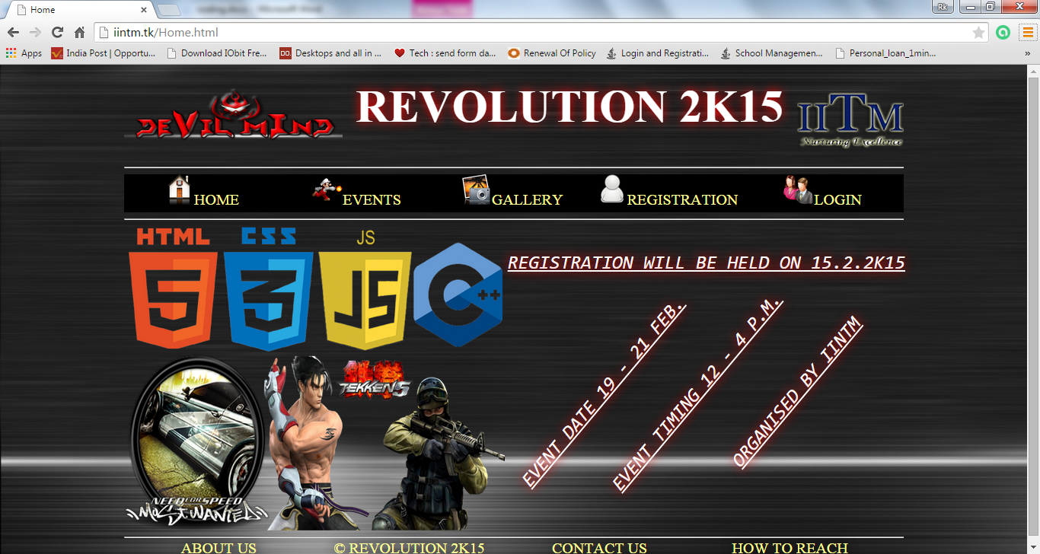

**Screenshot 4.2: Home Page**

* 1. **Event.html**

<!DOCTYPE html PUBLIC "-//W3C//DTD HTML 4.01 Transitional//EN" "http://www.w3.org/TR/html4/loose.dtd">

<html width="100%" height ="100%">

<head>

<script src="JS/Open.js"> </script>

<link rel="stylesheet" type="text/css" href="CSS/Html.css" />

<link rel="stylesheet" type="text/css" href="CSS/HtmlMenu.css" />

<link rel="stylesheet" type="text/css" href="CSS/FooterMenu.css" />

<meta http-equiv="Content-Type" content="text/html; charset=iso-8859-1" />

<title>Event</title>

</head>

<body>

<div id="Holder"><a href = "index.html"><img src="IMG/Logo1.png" align="left" width="287" height="100"/></a><a href = "http://iitmjp.ac.in/"><img src="IMG/Logo2.png" width="140" height="111" align="right"/></a>

<b id="name_ban"><center> REVOLUTION 2K15</center></b></br></br><hr/>

<div id="NavBar"><nav><ul>

<li><img src="IMG/Home.png" width="40" height="40"/><a href="index.html"style="text-decoration:none; color:inherit;">HOME</a></li>

<li><img src="IMG/event.jpg" width="40" height="40"/><a href="Event.html"style="text-decoration:none; color:inherit;">EVENTS</a></li>

<li><img src="IMG/gallery.png" width="40" height="40"/><a href="Gallary.html"style="text-decoration:none; color:inherit;">GALLERY</a></li>

<li><img src="IMG/registration.png" width="40" height="40"/><a href="javascript:Register()" style="text-decoration:none; color:inherit;">REGISTRATION</a></li>

<li><img src="IMG/login.png" width="40" height="40"/><a href="javascript:Login()" style="text-decoration:none; color:inherit;">LOGIN</a></li>

</ul></nav></div><hr /><b id="list1">

<a href="ARTI-CODE.html"style="text-decoration: none; color: inherit;">ARTI-CODE</a><br><br>

<a href="DEBUG.html"style="text-decoration: none; color: inherit;">BUG 2 DEBUG</a><br><br>

<a href="SPIDERWICK.html"style="text-decoration: none; color: inherit;">SPIDERWICK</a><br><br>

<a href="X-COMWAR.html"style="text-decoration: none; color: inherit;">X-COMWAR</a> </b> <img id="logo"src="IMG/Logo3.gif"/><br><br><

br><br><br><br><br><br><br><br><br><br><br><br><br><br><br><br><br><br><br>

<hr/><div id="FootBar"><Foot><ul>

<li><a href="About.html"style="text-decoration: none; color: inherit;">ABOUT US</a></li>

<li><a href="DevilTeam.html"style="text-decoration: none; color: inherit;">&copy; REVOLUTION 2K15</a></li>

<li><a href="Contact.html"style="text-decoration: none; color: inherit;">CONTACT US</li>

<li><a href="Howtoreach.html"style="text-decoration: none; color: inherit;"> HOW TO REACH</a></li> </ul> </Foot></div>

</body>

</html>

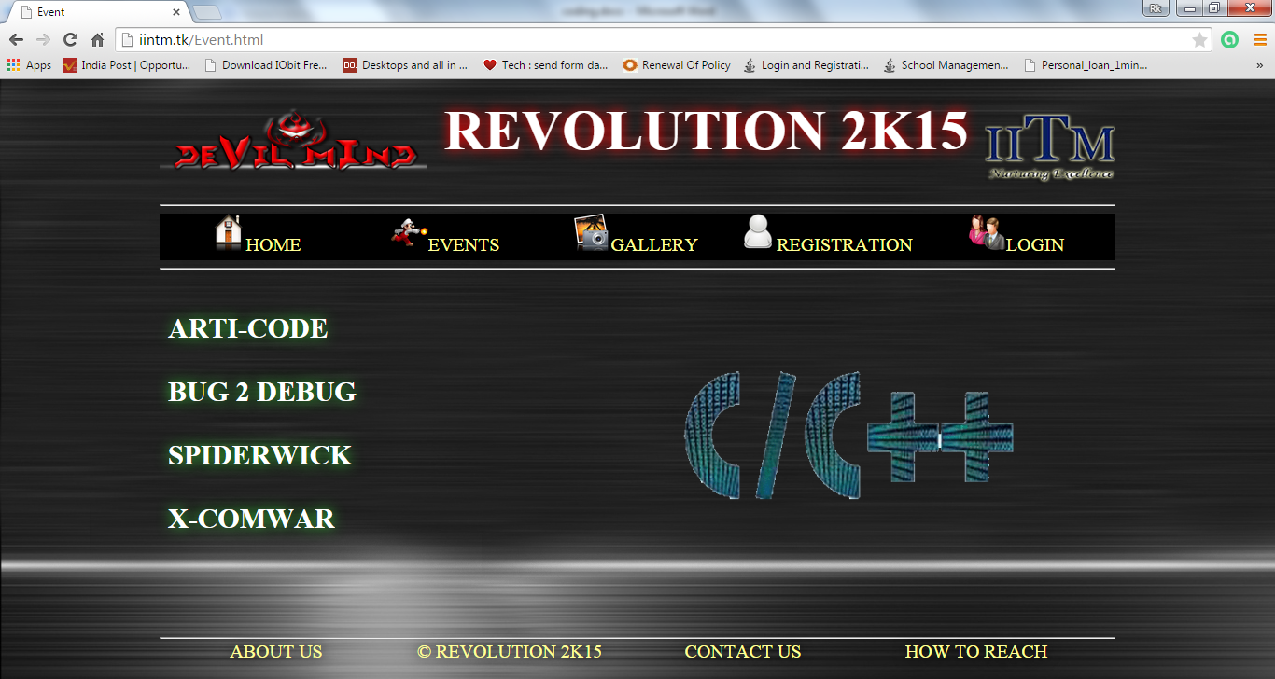

**Screenshot 4.3: Event Page**

* 1. **Gallery.html**

<!DOCTYPE html PUBLIC "-//W3C//DTD HTML 4.01 Transitional//EN" "http://www.w3.org/TR/html4/loose.dtd">

<html width="100%" height ="100%">

<head>

<script src="JS/Open.js"> </script>

<link rel="stylesheet" type="text/css" href="CSS/Html.css" />

<link rel="stylesheet" type="text/css" href="CSS/HtmlMenu.css" />

<link rel="stylesheet" type="text/css" href="CSS/FooterMenu.css" />

<meta http-equiv="Content-Type" content="text/html; charset=iso-8859-1" />

<title>College Gallary</title>

</head>

<body onLoad="javascript: sf.focus()">

<div id="Holder"><a href = "index.html"><img src="IMG/Logo1.png" align="left" width="287" height="100"/></a><a href = "http://iitmjp.ac.in/"><img src="IMG/Logo2.png" width="140" height="111" align="right"/></a>

<b id="name_ban"><center> REVOLUTION 2K15</center></b></br></br><hr/>

<div id="NavBar"><nav><ul>

<li><img src="IMG/Home.png" width="40" height="40"/><a href="index.html"style="text-decoration:none; color:inherit;">HOME</a></li>

<li><img src="IMG/event.jpg" width="40" height="40"/><a href="Event.html"style="text-decoration:none; color:inherit;">EVENTS</a></li>

<li><img src="IMG/gallery.png" width="40" height="40"/><a href="Gallary.html"style="text-decoration:none; color:inherit;">GALLERY</a></li>

<li><img src="IMG/registration.png" width="40" height="40"/><a href="javascript:Register()" style="text-decoration:none; color:inherit;">REGISTRATION</a></li>

<li><img src="IMG/login.png" width="40" height="40"/><a href="javascript:Login()" style="text-decoration:none; color:inherit;">LOGIN</a></li></ul></nav></div><hr />

<table width="100%" height="80%" border="4" bordercolor="#FFFFFF" bordercolorlight="#CCCCCC" bordercolordark="#FF0000">

<tr> <td align="center">

<object classid="clsid:D27CDB6E-AE6D-11cf-96B8-444553540000" codebase="http://download.macromedia.com/pub/shockwave/cabs/flash/swflash.cab#version=9.0.0.0" width="1000" height="370" ID="sf" VIEWASTEXT>

<param name="movie" value="Gallery.swf" />

<param name="quality" value="high" />

<param name="wmode" value="window" />

<param name="allowScriptAccess" value="always" />

<param name="allowFullScreen" value="true" />

<embed src="Gallery.swf" quality="high" name="sf" allowScriptAccess="always" allowFullScreen="true" pluginspage="http://www.macromedia.com/go/getflashplayer" type="application/x-shockwave-flash" width="1000" height="370" />

</object> </td> </tr> </table><hr/>

<div id="FootBar"> <Foot><ul>

<li><a href="About.html"style="text-decoration: none; color: inherit;">ABOUT US</a></li>

<li><a href="DevilTeam.html"style="text-decoration: none; color: inherit;">&copy; REVOLUTION 2K15</a></li>

<li><a href="Contact.html"style="text-decoration: none; color: inherit;">CONTACT US</li>

<li><a href="Howtoreach.html"style="text-decoration: none; color: inherit;"> HOW TO REACH</a></li> </ul> </Foot></div>

</body>

</html>

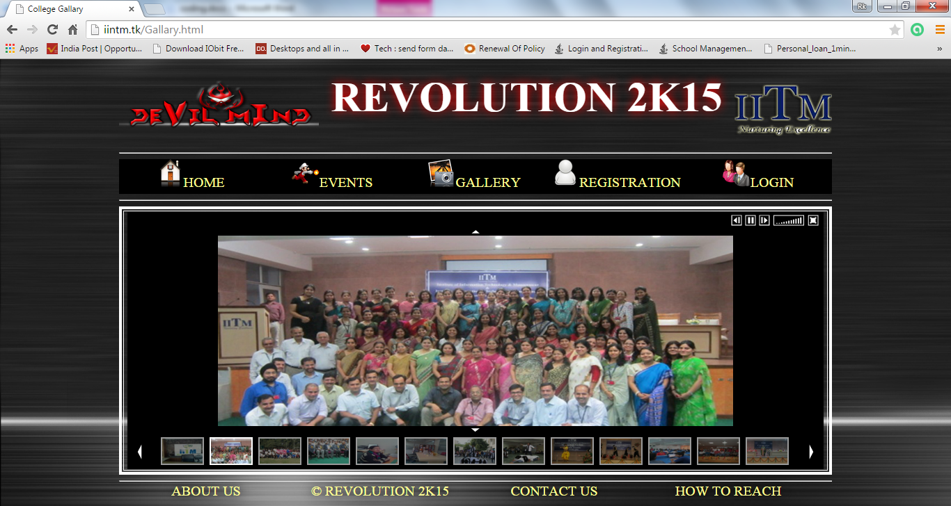

**Screenshot 4.4: Gallery Page**

* 1. **About.html**

<!DOCTYPE html PUBLIC "-//W3C//DTD HTML 4.01 Transitional//EN" "http://www.w3.org/TR/html4/loose.dtd">

<html width="100%" height ="100%">

<head>

<script src="JS/Open.js"> </script>

<link rel="stylesheet" type="text/css" href="CSS/Html.css" />

<link rel="stylesheet" type="text/css" href="CSS/HtmlMenu.css" />

<link rel="stylesheet" type="text/css" href="CSS/FooterMenu.css" />

<meta http-equiv="Content-Type" content="text/html; charset=iso-8859-1" />

<title>About</title>

</head>

<body>

<div id="Holder"><a href = "index.html"><img src="IMG/Logo1.png" align="left" width="287" height="100"/></a><a href = "http://iitmjp.ac.in/"><img src="IMG/Logo2.png" width="140" height="111" align="right"/></a>

<b id="name_ban"><center>REVOLUTION 2K15</center></b>

</br></br>

<hr/>

<div id="NavBar">

<nav>

<ul>

<li><img src="IMG/Home.png" width="40" height="40"/><a href="index.html"style="text-decoration:none; color:inherit;">HOME</a></li>

<li><img src="IMG/event.jpg" width="40" height="40"/><a href="Event.html"style="text-decoration:none; color:inherit;">EVENTS</a></li>

<li><img src="IMG/gallery.png" width="40" height="40"/><a href="Gallary.html"style="text-decoration:none; color:inherit;">GALLERY</a></li>

<li><img src="IMG/registration.png" width="40" height="40"/><a href="javascript:Register()" style="text-decoration:none; color:inherit;">REGISTRATION</a></li>

<li><img src="IMG/login.png" width="40" height="40"/><a href="javascript:Login()" style="text-decoration:none; color:inherit;">LOGIN</a></li>

</ul>

</nav>

</div>

<hr />

<br>

<table width="100%" border="10" style="border:5px groove cornflowerblue; padding:8px;">

<tr>

<td colspan="2"><div id="about" ><h3 align="center">About The Institute </h3></div></td>

</tr>

<tr id="about">

<td align="justify">

The institute aims to develop as a Centre of Excellence for imparting technical education and generating competent professionals with a high degree of credibility, integrity and ethical standards. The institute is passionate about grooming leaders who are not only thorough professionals, but also good human beings with values and &ldquo;sanskars&rdquo;.<br>

Education is a life-long process, but it must develop from firm and broad foundation. The goal of the institute is to inculcate in the students a love for learning and a desire to excel at every level. The institute also aims at equipping the students with the intellectual and practical skills that are necessary to meet the inevitable challenges in the future.<br>

The Institute has a sprawling campus where undergraduate programs in information technology and management are run in affiliation with Guru Gobind Singh Indraprastha University, Delhi and are approved by the Government of NCT of Delhi. The campus provides a pleasant and intellectually stimulating ambience. It has spacious Air-Conditioned lecture theatres, computer labs with 'I3' machines, a well stocked library and other essential infrastructural facilities.

</td>

<td><img src="IMG/iintm.jpeg" width="222" height="300" border="4" style ="border-color:#FFFFFF" align="right"></td>

</tr>

</table>

<hr/>

<div id="FootBar">

<Foot>

<ul>

<li><a href="About.html"style="text-decoration: none; color: inherit;">ABOUT US</a></li>

<li><a href="About.html"style="text-decoration: none; color: inherit;">&copy; REVOLUTION 2K15</a></li>

<li><a href="Contact.html"style="text-decoration: none; color: inherit;">CONTACT US</li>

<li><a href="Howtoreach.html"style="text-decoration: none; color: inherit;"> HOW TO REACH</a></li>

</ul>

</Foot>

</div>

</body>

</html>



**Screenshot 4.5: About Page**

* 1. **Contact.html**

<!DOCTYPE html PUBLIC "-//W3C//DTD HTML 4.01 Transitional//EN" "http://www.w3.org/TR/html4/loose.dtd">

<html width="100%" height ="100%">

<head>

<script src="JS/Open.js"> </script>

<link rel="stylesheet" type="text/css" href="CSS/Html.css" />

<link rel="stylesheet" type="text/css" href="CSS/HtmlMenu.css" />

<link rel="stylesheet" type="text/css" href="CSS/FooterMenu.css" />

<meta http-equiv="Content-Type" content="text/html; charset=iso-8859-1" />

<title>Contact</title>

</head>

<body>

<div id="Holder"><a href = "index.html"><img src="IMG/Logo1.png" align="left" width="287" height="100"/></a><a href = "http://iitmjp.ac.in/"><img src="IMG/Logo2.png" width="140" height="111" align="right"/></a>

<b id="name_ban"><center> REVOLUTION 2K15</center></b>

</br></br>

<hr/>

<div id="NavBar">

<nav>

<ul>

<li><img src="IMG/Home.png" width="40" height="40"/><a href="index.html"style="text-decoration:none; color:inherit;">HOME</a></li>

<li><img src="IMG/event.jpg" width="40" height="40"/><a href="Event.html"style="text-decoration:none; color:inherit;">EVENTS</a></li>

<li><img src="IMG/gallery.png" width="40" height="40"/><a href="Gallary.html"style="text-decoration:none; color:inherit;">GALLERY</a></li>

<li><img src="IMG/registration.png" width="40" height="40"/><a href="javascript:Register()" style="text-decoration:none; color:inherit;">REGISTRATION</a></li>

<li><img src="IMG/login.png" width="40" height="40"/><a href="javascript:Login()" style="text-decoration:none; color:inherit;">LOGIN</a></li>

</ul>

</nav>

</div>

<hr />

<table width="400" id="about1" align="center">

<tr>

<td width="106" align="center" valign="middle">

<label>Phone :-</label>

</td>

<td width="272" align="center" valign="middle">91-011-28520890, 28520894</td>

</tr>

<tr>

<td align="center" valign="middle">&nbsp;</td>

<td align="center" valign="middle">&nbsp;</td>

</tr>

<tr>

<td align="center" valign="middle"><label>Office Address :-</label>

</td>

<td align="center" valign="middle">D-27 &amp; 28 Institutional Area, Janakpuri, New Delhi-110058</td>

</tr>

</table>

<br><br><br><br><br><br><br><br><br><br><br><br><br><br><br><br><br><br><br><br><br>

<hr/>

<div id="FootBar">

<Foot>

<ul>

<li><a href="About.html"style="text-decoration: none; color: inherit;">ABOUT US</a></li>

<li><a href="DevilTeam.html"style="text-decoration: none; color: inherit;">&copy; REVOLUTION 2K15</a></li>

<li><a href="Contact.html"style="text-decoration: none; color: inherit;">CONTACT US</li>

<li><a href="Howtoreach.html"style="text-decoration: none; color: inherit;"> HOW TO REACH</a></li>

</ul>

</Foot>

</div>

</body>

</html>

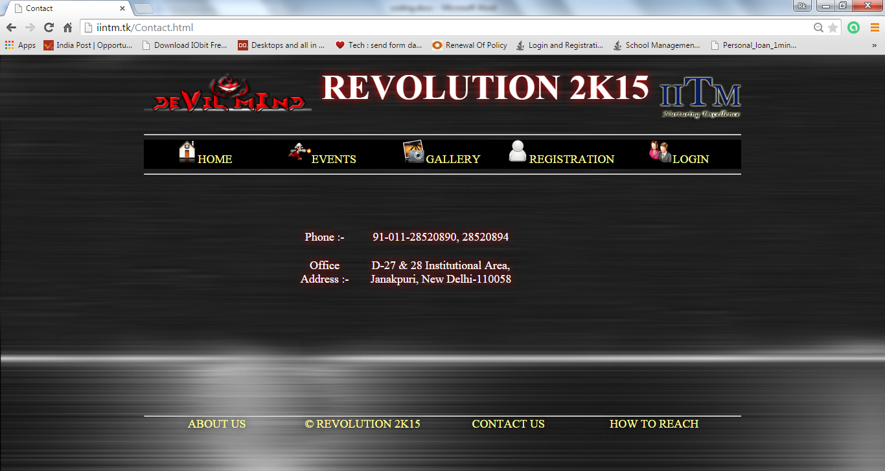

**Screenshot 4.6: Contact Page**

* 1. **Howtoreach.html**

<!DOCTYPE html PUBLIC "-//W3C//DTD HTML 4.01 Transitional//EN" "http://www.w3.org/TR/html4/loose.dtd">

<html width="100%" height ="100%">

<head>

<script src="JS/Open.js"> </script>

<link rel="stylesheet" type="text/css" href="CSS/Html.css" />

<link rel="stylesheet" type="text/css" href="CSS/HtmlMenu.css" />

<link rel="stylesheet" type="text/css" href="CSS/FooterMenu.css" />

<meta http-equiv="Content-Type" content="text/html; charset=iso-8859-1" />

<title>How To Reach</title>

</head>

<body>

<div id="Holder"><a href = "index.html"><img src="IMG/Logo1.png" align="left" width="287" height="100"/></a><a href = "http://iitmjp.ac.in/"><img src="IMG/Logo2.png" width="140" height="111" align="right"/></a>

<b id="name_ban"><center> REVOLUTION 2K15</center></b>

</br></br>

<hr/>

<div id="NavBar">

<nav>

<ul>

<li><img src="IMG/Home.png" width="40" height="40"/><a href="index.html"style="text-decoration:none; color:inherit;">HOME</a></li>

<li><img src="IMG/event.jpg" width="40" height="40"/><a href="Event.html"style="text-decoration:none; color:inherit;">EVENTS</a></li>

<li><img src="IMG/gallery.png" width="40" height="40"/><a href="Gallary.html"style="text-decoration:none; color:inherit;">GALLERY</a></li>

<li><img src="IMG/registration.png" width="40" height="40"/><a href="javascript:Register()" style="text-decoration:none; color:inherit;">REGISTRATION</a></li>

<li><img src="IMG/login.png" width="40" height="40"/><a href="javascript:Login()" style="text-decoration:none; color:inherit;">LOGIN</a></li>

</ul>

</nav>

</div>

<hr />

<script type="text/javascript" src="http://maps.google.com/maps/api/js?sensor=false"></script>

<div align="center" style="overflow:hidden;height:380px;width:1020px;">

<div align="center" id="gmap_canvas" style="height:380px;width:1020px;"></div>

<style>#gmap_canvas img{max-width:none!important;background:none!important}</style>

<a class="google-map-code" href="http://www.trivoo.net" id="get-map-data"></a></div>

<script type="text/javascript" >

function init_map()

{

var myOptions = {zoom:17,center:new google.maps.LatLng(28.6101014,77.10276799999997),mapTypeId: google.maps.MapTypeId.ROADMAP};

map = new google.maps.Map(document.getElementById("gmap_canvas"), myOptions);

marker = new google.maps.Marker({map: map,position: new google.maps.LatLng(28.6101014, 77.10276799999997)});

infowindow = new google.maps.InfoWindow({content:"<b>Institute of Innovation in Technology &amp; Management</b><br/>D-27 &amp; 28 Institutional Area, Janakpuri<br/>110058 New Delhi" });

google.maps.event.addListener(marker, "click", function(){infowindow.open(map,marker);});

infowindow.open(map,marker);

}

google.maps.event.addDomListener(window, 'load', init_map);</script>

<hr/>

<div id="FootBar">

<Foot>

<ul>

<li><a href="About.html"style="text-decoration: none; color: inherit;">ABOUT US</a></li>

<li><a href="DevilTeam.html"style="text-decoration: none; color: inherit;">&copy; REVOLUTION 2K15</a></li>

<li><a href="Contact.html"style="text-decoration: none; color: inherit;">CONTACT US</li>

<li><a href="Howtoreach.html"style="text-decoration: none; color: inherit;"> HOW TO REACH</a></li>

</ul>

</Foot>

</div>

</body>

</html>

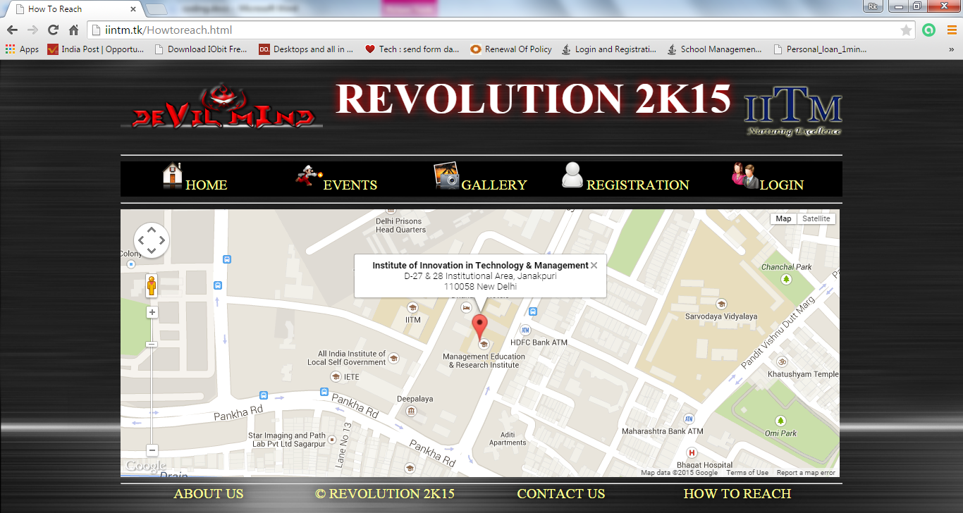

**Screenshot 4.7: Map Page**

* 1. **Register.php**

<?php require_once('Connections/mysql.php'); ?>

<?php

if (!function_exists("GetSQLValueString")) {

function GetSQLValueString($theValue, $theType, $theDefinedValue = "", $theNotDefinedValue = "")

{

if (PHP_VERSION < 6) {

$theValue = get_magic_quotes_gpc() ? stripslashes($theValue) : $theValue;

}

$theValue = function_exists("mysql_real_escape_string") ? mysql_real_escape_string($theValue) : mysql_escape_string($theValue);

switch ($theType) {

case "text":

$theValue = ($theValue != "") ? "'" . $theValue . "'" : "NULL";

break;

case "long":

case "int":

$theValue = ($theValue != "") ? intval($theValue) : "NULL";

break;

case "double":

$theValue = ($theValue != "") ? doubleval($theValue) : "NULL";

break;

case "date":

$theValue = ($theValue != "") ? "'" . $theValue . "'" : "NULL";

break;

case "defined":

$theValue = ($theValue != "") ? $theDefinedValue : $theNotDefinedValue;

break;

}

return $theValue;

}

}

// *** Redirect if username exists

$MM_flag="MM_insert";

if (isset($_POST[$MM_flag])) {

$MM_dupKeyRedirect="Register.php";

$loginUsername = $_POST['UserName'];

$LoginRS__query = sprintf("SELECT Username FROM register WHERE Username=%s", GetSQLValueString($loginUsername, "text"));

mysql_select_db($database_mysql, $mysql);

$LoginRS=mysql_query($LoginRS__query, $mysql) or die(mysql_error());

$loginFoundUser = mysql_num_rows($LoginRS);

//if there is a row in the database, the username was found - can not add the requested username

if($loginFoundUser){

$MM_qsChar = "?";

//append the username to the redirect page

if (substr_count($MM_dupKeyRedirect,"?") >=1) $MM_qsChar = "&";

$MM_dupKeyRedirect = $MM_dupKeyRedirect . $MM_qsChar ."requsername=".$loginUsername;

header ("Location: $MM_dupKeyRedirect");

exit;

}

}

$editFormAction = $_SERVER['PHP_SELF'];

if (isset($_SERVER['QUERY_STRING'])) {

$editFormAction .= "?" . htmlentities($_SERVER['QUERY_STRING']);

}

if ((isset($_POST["MM_insert"])) && ($_POST["MM_insert"] == "RegisterFrom")) {

$insertSQL = sprintf("INSERT INTO register (Fname, Lname, College, Course, Sem, Sid, Event, Mob, Email, Username, Password) VALUES (%s, %s, %s, %s, %s, %s, %s, %s, %s, %s, %s)",

GetSQLValueString($_POST['Fname'], "text"),

GetSQLValueString($_POST['Lname'], "text"),

GetSQLValueString($_POST['College'], "text"),

GetSQLValueString($_POST['Course'], "text"),

GetSQLValueString($_POST['Sem'], "text"),

GetSQLValueString($_POST['Eid'], "int"),

GetSQLValueString($_POST['Event'], "text"),

GetSQLValueString($_POST['Mobile'], "text"),

GetSQLValueString($_POST['Email'], "text"),

GetSQLValueString($_POST['UserName'], "text"),

GetSQLValueString($_POST['Password'], "text"));

mysql_select_db($database_mysql, $mysql);

$Result1 = mysql_query($insertSQL, $mysql) or die(mysql_error());

$insertGoTo = "RegisterSuccess.php";

if (isset($_SERVER['QUERY_STRING'])) {

$insertGoTo .= (strpos($insertGoTo, '?')) ? "&" : "?";

$insertGoTo .= $_SERVER['QUERY_STRING'];

}

header(sprintf("Location: %s", $insertGoTo));

}

mysql_select_db($database_mysql, $mysql);

$query_Register = "SELECT * FROM register";

$Register = mysql_query($query_Register, $mysql) or die(mysql_error());

$row_Register = mysql_fetch_assoc($Register);

$totalRows_Register = mysql_num_rows($Register);

?>

<!DOCTYPE html PUBLIC "-//W3C//DTD XHTML 1.0 Transitional//EN" "http://www.w3.org/TR/xhtml1/DTD/xhtml1-transitional.dtd">

<html xmlns="http://www.w3.org/1999/xhtml">

<head>

<link href="CSS/Layout.css" rel="stylesheet" type="text/css"/>

<link href="CSS/Menu.css" rel="stylesheet" type="text/css"/>

<link href="SpryAssets/SpryValidationTextField.css" rel="stylesheet" type="text/css" />

<meta http-equiv="Content-Type" content="text/html; charset=utf-8" />

<title>Register</title>

<script src="SpryAssets/SpryValidationTextField.js" type="text/javascript"></script>

</head>

<body>

<div id="Holder">

<div id="Header"></div>

<div id="NavBar">

<nav>

<ul>

<li><a href="Register.php">Register</a></li>

<li><a href="Login.php">Login</a></li>

<li><a href="AdminLogin.php">Admin Login</a></li>

</ul>

</nav>

</div>

<div id="Content">

<div id="PageHeading">

<h1 id="Text2">Sign Up!!</h1>

</div>

<div id="ContentLeft">

<h2 id="Text2">IINTM <br /><br /> Organising Online Technical Fest 2K15 ..</h2>

</div>

<div id="ContentRight">

<form action="<?php echo $editFormAction; ?>" id="RegisterFrom" name="RegisterFrom" method="POST">

<table width="400" border="0" align="center" id="Text">

<tr>

<td><table border="0">

<tr>

<td><span id="sprytextfield1">First Name:

<label for="Fname"></label>

<br />

<input name="Fname" type="text" class="StyleTextField" id="Fname" />

<span class="textfieldRequiredMsg">*</span></span></td>

<td><span id="sprytextfield2">Last Name:

<label for="Lname"></label>

<br />

<input name="Lname" type="text" class="StyleTextField" id="Lname" />

<span class="textfieldRequiredMsg">*</span></span></td>

</tr>

</table></td>

</tr>

<tr>

<td>&nbsp;</td>

</tr>

<tr>

<td><table border="0">

<tr>

<td><span id="sprytextfield3">College Name:

<label for="College"></label>

<br />

<input name="College" type="text" class="StyleTextField" id="College" />

<span class="textfieldRequiredMsg">*</span></span></td>

<td><span id="sprytextfield4">Course:

<label for="Course"></label>

<br />

<label for="Course"></label>

<select name="Course" id="Course" class="StyleTextField">

<option></option>

<option>BCA</option>

<option>BBA</option>

<option>BCAM</option>

<option>MCA</option>

</select>

<span class="textfieldRequiredMsg">*</span></span></td>

</tr>

</table></td>

</tr>

<tr>

<td>&nbsp;</td>

</tr>

<tr>

<td><table border="0">

<tr>

<td width="202"><span id="sprytextfield5">Semester:

<label for="Sem"></label>

<br />

<select name="Sem" id="Sem" class="StyleTextField">

<option></option>

<option>1st</option>

<option>2nd</option>

<option>3rd</option>

<option>4th</option>

<option>5th</option>

<option>6th</option>

</select>

<span class="textfieldRequiredMsg">*</span></span></td>

<td width="202"><span id="sprytextfield6">Enrollment No.

:<br />

<label for="Eid"></label>

<input name="Eid" type="text" class="StyleTextField" id="Eid" />

<span class="textfieldRequiredMsg">*</span></span></td>

</tr>

</table></td>

</tr>

<tr>

<td>&nbsp;</td>

</tr>

<tr>

<td><span id="sprytextfield7">Event:<br />

<label for="Event"></label>

<select name="Event" class="StyleTextField" id="Event"><option> </option>

<option> ARTI-CODE</option>

<option>BUG 2 DEBUG</option>

<option>SPIDERWICK</option>

<option>X-COMWAR</option>

</select>

<span class="textfieldRequiredMsg">*</span></span></td>

</tr>

<tr>

<td>&nbsp;</td>

</tr>

<tr>

<td><p>Mobile :<span id="sprytextfield12"><br />

<label for="Mobile"></label>

<input name="Mobile" type="text" size="10" class="StyleTextField" id="Mobile" />

<span class="textfieldRequiredMsg">*</span></span></p></td>

</tr>

<tr>

<td>&nbsp;</td>

</tr>

<tr>

<td><span id="sprytextfield8">User Name:<br />

<label for="UserName"></label>

<input name="UserName" type="text" class="StyleTextField" id="UserName" />

<span class="textfieldRequiredMsg">*</span></span></td>

</tr>

<tr>

<td>&nbsp;</td>

</tr>

<tr>

<td><span id="sprytextfield9">Email:<br />

<label for="Email"></label>

<input name="Email" type="text" class="StyleTextField" id="Email" />

<span class="textfieldRequiredMsg">*</span><span class="textfieldInvalidFormatMsg">Invalid format.</span></span></td>

</tr>

<tr>

<td>&nbsp;</td>

</tr>

<tr>

<td><table border="0">

<tr>

<td><span id="sprytextfield10">

<label for="Password"></label>Password:

<br />

<input name="Password" type="Password" class="StyleTextField" id="Password" />

<span class="textfieldRequiredMsg">*</span></span></td>

<td><span id="sprytextfield11">Confirm Password:

<label for="PasswordC"></label>

<br />

<input name="PasswordC" type="password" class="StyleTextField" id="PasswordC" />

<span class="textfieldRequiredMsg">*</span></span></td>

</tr>

</table></td>

</tr>

<tr>

<td>&nbsp;</td>

</tr>

<tr>

<td><div align="center">

<input type="submit" class="StyleTextField" name="RegisterButton" id="RegisterButton" value="Register" />

</div></td>

</tr>

</table>

<input type="hidden" name="MM_insert" value="RegisterFrom" />

</form>

</div>

</div>

<div id="Footer"></div>

</div>

<script type="text/javascript">

var sprytextfield1 = new Spry.Widget.ValidationTextField("sprytextfield1");

var sprytextfield2 = new Spry.Widget.ValidationTextField("sprytextfield2");

var sprytextfield3 = new Spry.Widget.ValidationTextField("sprytextfield3");

var sprytextfield4 = new Spry.Widget.ValidationTextField("sprytextfield4");

var sprytextfield5 = new Spry.Widget.ValidationTextField("sprytextfield5");

var sprytextfield6 = new Spry.Widget.ValidationTextField("sprytextfield6");

var sprytextfield7 = new Spry.Widget.ValidationTextField("sprytextfield7");

var sprytextfield8 = new Spry.Widget.ValidationTextField("sprytextfield8");

var sprytextfield9 = new Spry.Widget.ValidationTextField("sprytextfield9", "email");

var sprytextfield10 = new Spry.Widget.ValidationTextField("sprytextfield10");

var sprytextfield11 = new Spry.Widget.ValidationTextField("sprytextfield11");

var sprytextfield12 = new Spry.Widget.ValidationTextField("sprytextfield12");

</script>

</body>

</html>

<?php

mysql_free_result($Register);

?>

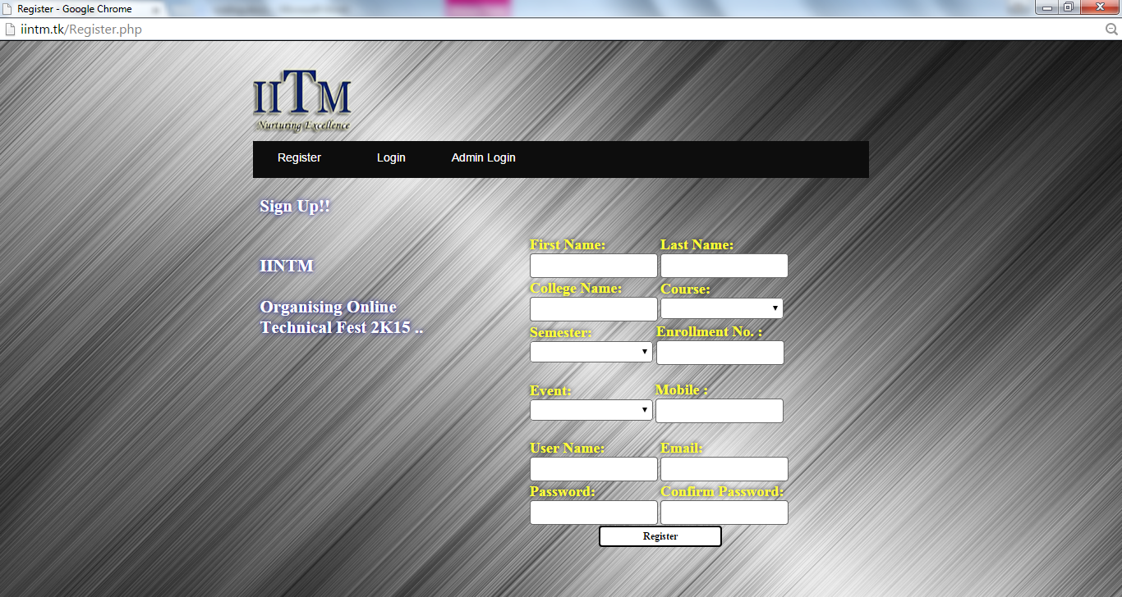

**Screenshot 4.8: Registration Page**

* 1. **Login.php**

<?php require_once('Connections/mysql.php'); ?>

<?php

@session_start();

if (!function_exists("GetSQLValueString")) {

function GetSQLValueString($theValue, $theType, $theDefinedValue = "", $theNotDefinedValue = "")

{

if (PHP_VERSION < 6) {

$theValue = get_magic_quotes_gpc() ? stripslashes($theValue) : $theValue;

}

$theValue = function_exists("mysql_real_escape_string") ? mysql_real_escape_string($theValue) : mysql_escape_string($theValue);

switch ($theType) {

case "text":

$theValue = ($theValue != "") ? "'" . $theValue . "'" : "NULL";

break;

case "long":

case "int":

$theValue = ($theValue != "") ? intval($theValue) : "NULL";

break;

case "double":

$theValue = ($theValue != "") ? doubleval($theValue) : "NULL";

break;

case "date":

$theValue = ($theValue != "") ? "'" . $theValue . "'" : "NULL";

break;

case "defined":

$theValue = ($theValue != "") ? $theDefinedValue : $theNotDefinedValue;

break;

}

return $theValue;

}

}

mysql_select_db($database_mysql, $mysql);

$query_Login = "SELECT * FROM register";

$Login = mysql_query($query_Login, $mysql) or die(mysql_error());

$row_Login = mysql_fetch_assoc($Login);

$totalRows_Login = mysql_num_rows($Login);

?>

<?php

// *** Validate request to login to this site.

if (!isset($_SESSION)) {

session_start();

}

$loginFormAction = $_SERVER['PHP_SELF'];

if (isset($_GET['accesscheck'])) {

$_SESSION['PrevUrl'] = $_GET['accesscheck'];

}

if (isset($_POST['Username'])) {

$loginUsername=$_POST['Username'];

$password=$_POST['Password'];

$MM_fldUserAuthorization = "";

$MM_redirectLoginSuccess = "Account.php";

$MM_redirectLoginFailed = "InvalidLogin.php";

$MM_redirecttoReferrer = true;

mysql_select_db($database_mysql, $mysql);

$LoginRS__query=sprintf("SELECT Username, Password FROM register WHERE Username=%s AND Password=%s",

GetSQLValueString($loginUsername, "text"), GetSQLValueString($password, "text"));

$LoginRS = mysql_query($LoginRS__query, $mysql) or die(mysql_error());

$loginFoundUser = mysql_num_rows($LoginRS);

if ($loginFoundUser) {

$loginStrGroup = "";

if (PHP_VERSION >= 5.1) {session_regenerate_id(true);} else {session_regenerate_id();}

//declare two session variables and assign them

$_SESSION['MM_Username'] = $loginUsername;

$_SESSION['MM_UserGroup'] = $loginStrGroup;

if (isset($_SESSION['PrevUrl']) && true) {

$MM_redirectLoginSuccess = $_SESSION['PrevUrl'];

}

header("Location: " . $MM_redirectLoginSuccess );

}

else {

header("Location: ". $MM_redirectLoginFailed );

}

}

?>

<!DOCTYPE html PUBLIC "-//W3C//DTD XHTML 1.0 Transitional//EN" "http://www.w3.org/TR/xhtml1/DTD/xhtml1-transitional.dtd">

<html xmlns="http://www.w3.org/1999/xhtml">

<head>

<link href="CSS/Layout.css" rel="stylesheet" type="text/css"/>

<link href="CSS/Menu.css" rel="stylesheet" type="text/css"/>

<link href="SpryAssets/SpryValidationTextField.css" rel="stylesheet" type="text/css" />

<meta http-equiv="Content-Type" content="text/html; charset=utf-8" />

<title>Login</title>

<script src="SpryAssets/SpryValidationTextField.js" type="text/javascript"></script>

</head>

<body>

<div id="Holder">

<div id="Header"></div>

<div id="NavBar">

<nav>

<ul>

<li><a href="Register.php">Register</a></li>

<li><a href="Login.php">Login</a></li>

<li><a href="AdminLogin.php">Admin Login</a></li>

</ul>

</nav>

</div>

<div id="Content">

<div id="PageHeading">

<h1 id="Text2"> Login !</h1>

</div>

<div id="ContentLeft">

<h2 id="Text2">IINTM <br /><br />Organising Online Technical Fest 2K15 ..</h2>

</div>

<div id="ContentRight">

<form ACTION="<?php echo $loginFormAction; ?>" id="LoginForm" name="LoginForm" method="POST">

<table width="400" border="0" align="center" >

<tr> </tr>

<tr> </tr>

</table>

<table width="456" border="0" align="center" id="Text">

<tr>

<td width="423"><h3>Username : <span id="sprytextfield1">

<label for="Username2"></label>

<input name="Username" type="text" class="StyleTextField" id="Username2" />

<span class="textfieldRequiredMsg">*</span></span></h3></td>

</tr>

<tr>

<td><h3>Password : <span id="sprytextfield2">

<label for="Password"></label>

<input name="Password" type="Password" class="StyleTextField" id="Password" />

<span class="textfieldRequiredMsg">*</span></span></h3></td>

</tr>

<tr>

<td>&nbsp;</td>

</tr> <tr>

<td align="center"><input name="LoginButton" type="submit" class="StyleButton" id="LoginButton" value="Login" /></td>

</tr> <tr>

<td align="center"><strong><a href="ForgotPassword.php">Forgot Password..!!!</a></strong></td>

</tr>

</table>

</form>

</div></div>

<div id="Footer"></div>

</div>

<script type="text/javascript">

var sprytextfield1 = new Spry.Widget.ValidationTextField("sprytextfield1");

var sprytextfield2 = new Spry.Widget.ValidationTextField("sprytextfield2");

</script></body>

</html>

<?php

mysql_free_result($Login);

?>

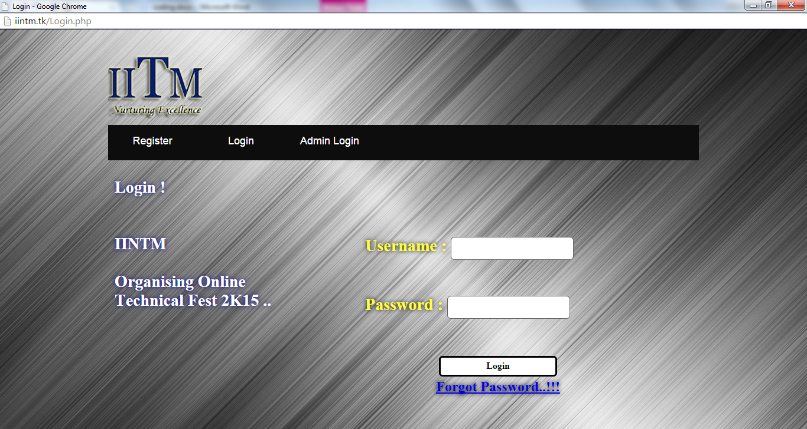

**Screenshot 4.9: Student Login Page**

* 1. **RegisterSuccess.php**

<!DOCTYPE html PUBLIC "-//W3C//DTD XHTML 1.0 Transitional//EN" "http://www.w3.org/TR/xhtml1/DTD/xhtml1-transitional.dtd">

<html xmlns="http://www.w3.org/1999/xhtml">

<head>

<link href="CSS/Layout.css" rel="stylesheet" type="text/css"/>

<link href="CSS/Menu.css" rel="stylesheet" type="text/css"/>

<meta http-equiv="Content-Type" content="text/html; charset=utf-8" />

<title>Successfully Register</title>

</head>

<body>

<div id="Holder">

<div id="Header"></div>

<div id="NavBar">

<nav>

<ul>

<li><a href="Register.php">Register</a></li>

<li><a href="Login.php">Login</a></li>

<li><a href="AdminLogin.php">Admin Login</a></li>

</ul>

</nav>

</div>

<div id="Content">

<div id="PageHeading">

<h1 id="Text3">Successfully Registered....!!!</h1>

</div>

<div id="ContentLeft">

<h2>&nbsp;</h2>

</div>

<div id="ContentRight">

<form id="RegisterFrom" name="RegisterFrom" method="POST">

</form>

</div>

</div>

<div id="Footer"></div>

</div>

</body>

</html>



**Screenshot 4.10: Success Page**

* 1. **Account.php**

<?php @session_start(); ?>

<?php require_once('Connections/mysql.php'); ?>

<?php

if (!function_exists("GetSQLValueString")) {

function GetSQLValueString($theValue, $theType, $theDefinedValue = "", $theNotDefinedValue = "")

{

if (PHP_VERSION < 6) {

$theValue = get_magic_quotes_gpc() ? stripslashes($theValue) : $theValue;

}

$theValue = function_exists("mysql_real_escape_string") ? mysql_real_escape_string($theValue) : mysql_escape_string($theValue);

switch ($theType) {

case "text":

$theValue = ($theValue != "") ? "'" . $theValue . "'" : "NULL";

break;

case "long":

case "int":

$theValue = ($theValue != "") ? intval($theValue) : "NULL";

break;

case "double":

$theValue = ($theValue != "") ? doubleval($theValue) : "NULL";

break;

case "date":

$theValue = ($theValue != "") ? "'" . $theValue . "'" : "NULL";

break;

case "defined":

$theValue = ($theValue != "") ? $theDefinedValue : $theNotDefinedValue;

break;

}

return $theValue;

}

}

$colname_User = "-1";

if (isset($_SESSION['MM_Username'])) {

$colname_User = $_SESSION['MM_Username'];

}

mysql_select_db($database_mysql, $mysql);

$query_User = sprintf("SELECT * FROM register WHERE Username = %s", GetSQLValueString($colname_User, "text"));

$User = mysql_query($query_User, $mysql) or die(mysql_error());

$row_User = mysql_fetch_assoc($User);

$totalRows_User = mysql_num_rows($User);

$WhereSQL = sprintf("SELECT * FROM event WHERE Event_Key ="+$_POST['EventID'],GetSQLValueString($_POST['EventhiddenField'], "int"));

switch ($WhereSQL)

{

case "391993": header('Location: SPIDERWICK.php');

break;

case "651993": header('Location: ARTI-CODE.php');

break;

case "951994": header('Location: BUG 2 DEBUG.php');

break;

case "2221994": header('Location: X-COMWAR.php');

break;

}

?>

<!DOCTYPE html PUBLIC "-//W3C//DTD XHTML 1.0 Transitional//EN" "http://www.w3.org/TR/xhtml1/DTD/xhtml1-transitional.dtd">

<html xmlns="http://www.w3.org/1999/xhtml">

<head>

<link href="CSS/Layout.css" rel="stylesheet" type="text/css"/>

<link href="CSS/Menu.css" rel="stylesheet" type="text/css"/>

<link href="SpryAssets/SpryValidationTextField.css" rel="stylesheet" type="text/css" />

<meta http-equiv="Content-Type" content="text/html; charset=utf-8" />

<title>Account</title>

<script src="SpryAssets/SpryValidationTextField.js" type="text/javascript"></script>

</head>

<body>

<div id="Holder">

<div id="Header"></div>

<div id="NavBar">

<nav>

<ul>

<li><a href="LogOut.php">Logout</a></li>

</ul>

</nav>

</div>

<div id="Content">

<div id="PageHeading">

<h1 id="Text3">Welcome, <?php echo $row_User['Fname']; ?> <?php echo $row_User['Lname']; ?> !</h1>

</div>

<div id="ContentLeft">

</div>

<div id="ContentRight">

<div align="center">

<form id="Event" name="Event" action="" method="POST">

<table width="230" align="center" bgcolor="#FFFFFF" border="4">

<tr align="center">

<td><strong>Event Keys</strong></td>

<td><strong>Event Name</strong></td>

</tr>

<tr align="center">

<td width="88"><strong>391993</strong></td>

<td width="115"><strong>SPIDERWICK</strong></td>

</tr>

<tr align="center">

<td><strong>651993</strong></td>

<td><strong>ARTI-CODE</strong></td>

</tr>

<tr align="center">

<td><strong>951994</strong></td>

<td><strong>BUG 2 DEBUG</strong></td>

</tr>

<tr align="center">

<td><strong>2221994</strong></td>

<td><strong>X-COMWAR</strong></td>

</tr>

</table>

<h1 id="Text2">Enter Event Key: <span id="sprytextfield1">

<label for="EventKey"></label>

<input name="EventID" type="text" class="StyleTextField" id="EventID" />

<span class="textfieldRequiredMsg">Enter Valid Key</span></span>

<input name="EventhiddenField" type="hidden" id="EventhiddenField"/>

</br></br>

<input name="EventBtn" type="submit" class="StyleTextField" id="EventBtn" value="Enter" />

</h1>

</form>

</div>

</div>

</div>

<div id="Footer"></div>

</div>

<script type="text/javascript">

var sprytextfield1 = new Spry.Widget.ValidationTextField("sprytextfield1");

</script>

</body>

</html>

<?php mysql_free_result($User); ?>

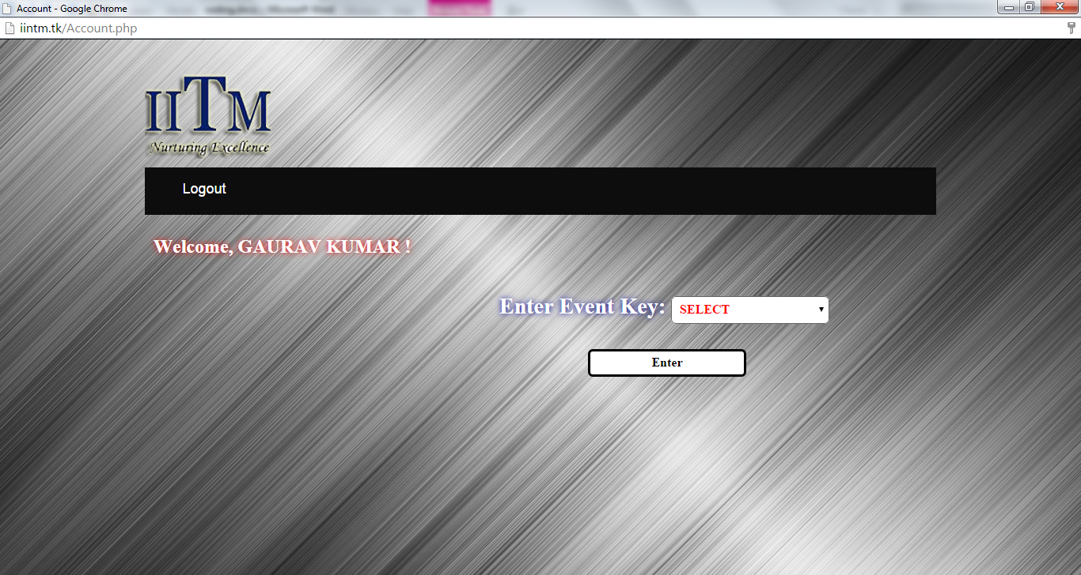

**Screenshot 4.11: User Account Page**

* 1. **Test.php**

<?php require_once('Connections/mysql.php'); ?>

<?php @session_start(); ?>

<?php

if (!function_exists("GetSQLValueString")) {

function GetSQLValueString($theValue, $theType, $theDefinedValue = "", $theNotDefinedValue = "")

{

if (PHP_VERSION < 6) {

$theValue = get_magic_quotes_gpc() ? stripslashes($theValue) : $theValue;

}

$theValue = function_exists("mysql_real_escape_string") ? mysql_real_escape_string($theValue) : mysql_escape_string($theValue);

switch ($theType) {

case "text":

$theValue = ($theValue != "") ? "'" . $theValue . "'" : "NULL";

break;

case "long":

case "int":

$theValue = ($theValue != "") ? intval($theValue) : "NULL";

break;

case "double":

$theValue = ($theValue != "") ? doubleval($theValue) : "NULL";

break;

case "date":

$theValue = ($theValue != "") ? "'" . $theValue . "'" : "NULL";

break;

case "defined":

$theValue = ($theValue != "") ? $theDefinedValue : $theNotDefinedValue;

break;

}

return $theValue;

}

}

$colname_User = "-1";

if (isset($_SESSION['MM_Username'])) {

$colname_User = $_SESSION['MM_Username'];

}

mysql_select_db($database_mysql, $mysql);

$query_User = sprintf("SELECT * FROM register WHERE Username = %s", GetSQLValueString($colname_User, "text"));

$User = mysql_query($query_User, $mysql) or die(mysql_error());

$row_User = mysql_fetch_assoc($User);

$totalRows_User = mysql_num_rows($User);

@session_start();

?><?php

if(isset($_POST["Submit"]))

{

$Fname = $_POST['Fname'];

$EventName = $_POST['EventName'];

$Score=0;

$answer1 = $_POST['Ques1'];

$answer2 = $_POST['Ques2'];

$answer3 = $_POST['Ques3'];

$answer4 = $_POST['Ques4'];

$answer5 = $_POST['Ques5'];

$answer6 = $_POST['Ques6'];

$answer7 = $_POST['Ques7'];

$answer8 = $_POST['Ques8'];

$answer9 = $_POST['Ques9'];

$answer10 = $_POST['Ques10'];

if($answer1 == "b")

{

$Score++;

}

if($answer2 == "a")

{

$Score++;

}

if($answer3 == "a")

{

$Score++;

}

if($answer4 == "b")

{

$Score++;

}

if($answer5 == "d")

{

$Score++;

}

if($answer6 == "c")

{

$Score++;

}

if($answer7 == "b")

{

$Score++;

}

if($answer8 == "a")

{

$Score++;

}

if($answer9 == "c")

{

$Score++;

}

if($answer10 == "a")

{

$Score++;

}

$sql="INSERT INTO result (FullName,Event_Name,Score) VALUES ('$Fname','$EventName','$Score')";

$result = mysql_query($sql);

if($result)

{

header('Location: ProcessTest.php');

}

}

@session_destroy();

?>

<!DOCTYPE html PUBLIC "-//W3C//DTD XHTML 1.0 Transitional//EN" "http://www.w3.org/TR/xhtml1/DTD/xhtml1-transitional.dtd">

<html xmlns="http://www.w3.org/1999/xhtml">

<head>

<link href="CSS/Layout.css" rel="stylesheet" type="text/css"/>

<link href="CSS/Menu.css" rel="stylesheet" type="text/css"/>

<link href="SpryAssets/SpryValidationTextField.css" rel="stylesheet" type="text/css" />

<meta http-equiv="Content-Type" content="text/html; charset=utf-8" />

<title>ARTI-CODE</title>

</head>

<body>

<div id="Holder">

<div id="Header"></div>

<div id="Content">

<form id="QuizTest" name="QuizTest" method="post" action="">

<div id="Text3">

<input name="Fname" type="text" class="StyleTextField2" id="Fname" readonly="readonly" value="<?php echo $row_User['Fname']; ?> <?php echo $row_User['Lname']; ?>" /> </div>

<br/><br/>

<table border="2" bgcolor="#CCCCCC" bordercolor="#000000" ><td><br/>

<center>

<input name="EventName" type="text" class="StyleTextField2" id="EventName" value = " ARTI-CODE" readonly="readonly" align="middle"/></center>

<table width="900" align="center">

<tr>

<td>All Questions Compulsory &amp; No Negative Marking..</td>

</tr>

<tr>

<td><p>1. Which specification that provides runtime environment in which java byte code can be executed?</p>

<p>

<label>

<input type="radio" name="Ques1" value="a" id="Ques1" />

JDK</label>

<br />

<label>

<input type="radio" name="Ques1" value="b" id="Ques1" />

JVM</label>

<br />

<label>

<input type="radio" name="Ques1" value="c" id="Ques1" />

JRE</label>

<br />

<label>

<input type="radio" name="Ques1" value="d" id="Ques1" />

None of the above</label>

</p></td>

</tr>

<tr>

<td>2. Which is an application designed to be transmitted over the Internet and executed by a Java-compatible Web browser?<br /> <br />

<label>

<input type="radio" name="Ques2" value="a" id="Ques2" />

An Applet</label>

<br />

<label>

<input type="radio" name="Ques2" value="b" id="Ques2" />

An Application</label>

<br />

<label>

<input type="radio" name="Ques2" value="c" id="Ques2" />

Both A &amp; B</label>

<br />

<label>

<input type="radio" name="Ques2" value="d" id="Ques2" />

None of the above</label> <br />

</td>

</tr>

<tr>

<td><p>3. Which are used to produce a programming environment that supports the development of far more robust and scalable programs than does the process-oriented model?</p>

<p>

<label>

<input type="radio" name="Ques3" value="a" id="Ques3" />

Polymorphism, Encapsulation, and Inheritance</label>

<br />

<label>

<input type="radio" name="Ques3" value="b" id="Ques3" />

Encapsulation and Inheritance</label>

<br />

<label>

<input type="radio" name="Ques3" value="c" id="Ques3" />

Polymorphism and Encapsulation</label>

<br />

<label>

<input type="radio" name="Ques3" value="d" id="Ques3" />

Inheritance and Polymorphism</label>

<br />

</p></td>

</tr>

<tr>

<td>4. In this type one super-class is having more than one sub-class?<br />

<br />

<label>

<input type="radio" name="Ques4" value="a" id="Ques4" /></label>

<label> Single inheritance</label>

<br />

<label>

<input type="radio" name="Ques4" value="b" id="Ques4" />

</label>

Hierarchical inheritance<br />

<label>

<input type="radio" name="Ques4" value="c" id="Ques4" />

Multiple inheritances</label>

<br />

<label>

<input type="radio" name="Ques4" value="d" id="Ques4" />

Multilevel inheritance

<br />

<br />

</label></td>

</tr>

<tr>

<td>5. Which symbol Used to contain the values of automatically initialized arrays. Also used<br />

&nbsp;&nbsp;&nbsp;&nbsp;To define a block of code, for classes, methods, and local scopes?<br />

<br />

<label>

<input type="radio" name="Ques5" value="a" id="Ques5" />

Brackets</label>

<br />

<label>

<input type="radio" name="Ques5" value="b" id="Ques5" />

Parentheses</label>

<br />

<label>

<input type="radio" name="Ques5" value="c" id="Ques5" />

Semicolon</label>

<br />

<label>

<input type="radio" name="Ques5" value="d" id="Ques5" />

Braces

<br />

</label></td>

</tr>

<tr>

<td><p>6. Which data type has this Minimum and Maximum value 3.4e-038 to 3.4e+038?</p>

<p>

<label>

<input type="radio" name="Ques6" value="a" id="Ques6" />

long</label>

<br />

<label>

<input type="radio" name="Ques6" value="b" id="Ques6" />

Int</label>

<br />

<label>

<input type="radio" name="Ques6" value="c" id="Ques6" />

Float</label>

<br />

<label>

<input type="radio" name="Ques6" value="d" id="Ques6" />

Byte</label>

</p></td>

</tr>

<tr>

<td>7. Which variables are created when an object is created with the use of the keyword 'new' and destroyed when the object is destroyed?<br />

<br />

<label>

<input type="radio" name="Ques7" value="a" id="Ques7" />

Local variables</label>

<br />

<label>

<input type="radio" name="Ques7" value="b" id="Ques7" />

Instance variables</label>

<br />

<label>

<input type="radio" name="Ques7" value="c" id="Ques7" />

Class Variables</label>

<br />

<label>

<input type="radio" name="Ques7" value="d" id="Ques7" />

Static variables

<br />

<br />

</label></td>

</tr>

<tr>

<td>8. Who is also called father of Java Programming Language?<br />

<br />

<label>

<input type="radio" name="Ques8" value="a" id="Ques8" />

James Gosling</label>

<br />

<label>

<input type="radio" name="Ques8" value="b" id="Ques8" />

Ken Thompson</label>

<br />

<label>

<input type="radio" name="Ques8" value="c" id="Ques8" />

Dennis Richie</label>

<br />

<label>

<input type="radio" name="Ques8" value="d" id="Ques8" />

None of the above<br />

<br />

</label></td>

</tr>

<tr>

<td>9. In control statements break, continue, return, try-catch-finally and assert belongs to ?

<br/><br />

<label>

<input type="radio" name="Ques9" value="a" id="Ques9" />

Selection statements</label>

<br />

<label>

<input type="radio" name="Ques9" value="b" id="Ques9" />

Loop Statements</label>

<br />

<label>

<input type="radio" name="Ques9" value="c" id="Ques9" />

Transfer statements</label>

<br />

<label>

<input type="radio" name="Ques9" value="d" id="Ques9" />

None of the above<br />

<br />

</label>

</p></td>

</tr>

<tr>

<td>10.What output you will get if you run this program?<br />

&nbsp;&nbsp;&nbsp;&nbsp;&nbsp;&nbsp;class Modulus {<br />

&nbsp;&nbsp;&nbsp;&nbsp;&nbsp;&nbsp; public static void main(String args[]) {<br />

&nbsp;&nbsp;&nbsp;&nbsp;&nbsp;&nbsp; int x = 42;<br />

&nbsp;&nbsp;&nbsp;&nbsp;&nbsp;&nbsp;double y = 42.25;<br />

&nbsp;&nbsp;&nbsp;&nbsp;&nbsp;&nbsp; System.out.println(&quot;x mod 10 = &quot; + x % 10);<br />

&nbsp;&nbsp;&nbsp;&nbsp;&nbsp;&nbsp;System.out.println(&quot;y mod 10 = &quot; + y % 10);<br />

&nbsp;&nbsp;&nbsp;&nbsp;&nbsp;&nbsp; }<br />

&nbsp;&nbsp;&nbsp;&nbsp;&nbsp;&nbsp; }<br />

<br />

<label>

<input type="radio" name="Ques10" value="a" id="Ques10" />

x mod 10 = 2 <br />

&nbsp;&nbsp;&nbsp;&nbsp;&nbsp;&nbsp;y mod 10 = 2.25</label>

<br />

<label>

<input type="radio" name="Ques10" value="b" id="Ques10" /></label>

x mod 10 = 4<br />

&nbsp;&nbsp;&nbsp;&nbsp;&nbsp;&nbsp;y mod 10 = 2.50 <br />

<label>

<input type="radio" name="Ques10" value="c" id="Ques10" /></label>

x mod 10 = 6<br />

&nbsp;&nbsp;&nbsp;&nbsp;&nbsp;&nbsp;y mod 10 = 3.25<br />

<label>

<input type="radio" name="Ques10" value="d" id="Ques10" />

None of the above<br />

</label></td>

</tr>

<tr> <td>&nbsp;</td> </tr>

<tr>

<td align="center" ><input name="Submit" type="submit" class="StyleButton" id="Submit" value="Submit" /></td>

</tr>

</table><br/></td></table>

</form>

</div></div>

<div id="Footer"></div></div>

</body>

</html>

<?php

mysql_free_result($User);

@session_destroy();

@session_unset();

?>

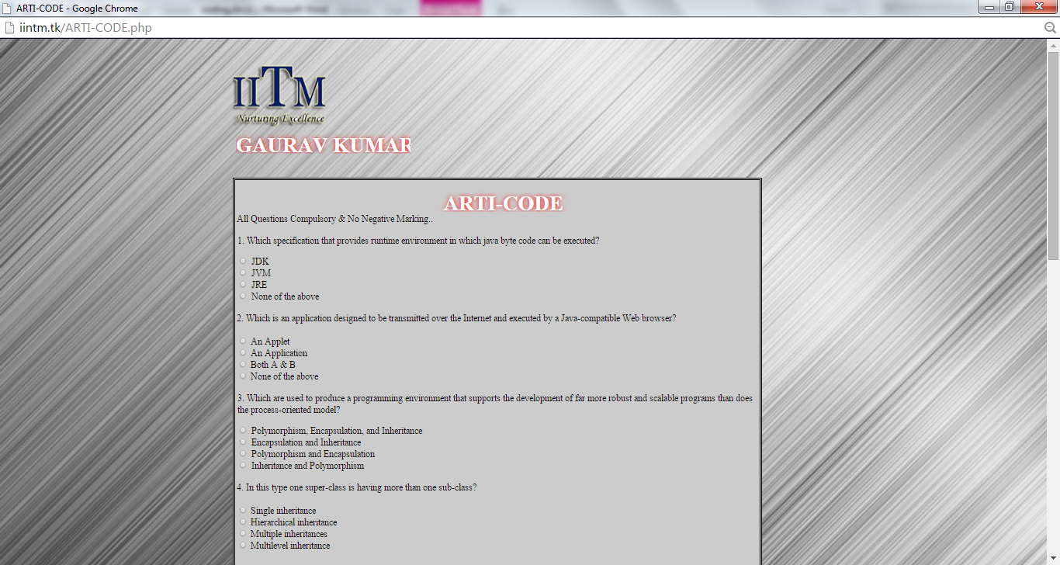

**Screenshot 4.12: MCQ Test Page**

* 1. **ProcessTest.php**

<?php require_once('Connections/mysql.php'); ?>

<?php @session_start(); ?>

<!DOCTYPE html PUBLIC "-//W3C//DTD XHTML 1.0 Transitional//EN" "http://www.w3.org/TR/xhtml1/DTD/xhtml1-transitional.dtd">

<html xmlns="http://www.w3.org/1999/xhtml">

<head>

<link href="CSS/Layout.css" rel="stylesheet" type="text/css"/>

<link href="CSS/Menu.css" rel="stylesheet" type="text/css"/>

<link href="SpryAssets/SpryValidationTextField.css" rel="stylesheet" type="text/css" />

<meta http-equiv="Content-Type" content="text/html; charset=utf-8" />

<title>Test SuccessFully Submitted</title>

</head>

<body>

<div id="Holder">

<a href="Login.php"><div id="Header"></div></a>

<div id="Content">

<div id="PageHeading">

<div id="Text3">

<h1 align="center">

<?php

echo"Test SuccessFully Submitted......!!";

@session_destroy();

@session_unset();

header( "refresh:5;url=Login.php" );

?>

</h1>

</div>

</div>

<div id="Footer"></div>

</div>

</body>

</html>



**Screenshot 4.13: Process Page**

* 1. **AdminLogin.php**

<?php @session_start();?>

<?php require_once('Connections/mysql.php'); ?>

<?php

if (!function_exists("GetSQLValueString")) {

function GetSQLValueString($theValue, $theType, $theDefinedValue = "", $theNotDefinedValue = "")

{

if (PHP_VERSION < 6) {

$theValue = get_magic_quotes_gpc() ? stripslashes($theValue) : $theValue;

}

$theValue = function_exists("mysql_real_escape_string") ? mysql_real_escape_string($theValue) : mysql_escape_string($theValue);

switch ($theType) {

case "text":

$theValue = ($theValue != "") ? "'" . $theValue . "'" : "NULL";

break;

case "long":

case "int":

$theValue = ($theValue != "") ? intval($theValue) : "NULL";

break;

case "double":

$theValue = ($theValue != "") ? doubleval($theValue) : "NULL";

break;

case "date":

$theValue = ($theValue != "") ? "'" . $theValue . "'" : "NULL";

break;

case "defined":

$theValue = ($theValue != "") ? $theDefinedValue : $theNotDefinedValue;

break;

}

return $theValue;

}

}

mysql_select_db($database_mysql, $mysql);

$query_AdminLogin = "SELECT * FROM `admin`";

$AdminLogin = mysql_query($query_AdminLogin, $mysql) or die(mysql_error());

$row_AdminLogin = mysql_fetch_assoc($AdminLogin);

$totalRows_AdminLogin = mysql_num_rows($AdminLogin);

?>

<?php

// *** Validate request to login to this site.

if (!isset($_SESSION)) {

session_start();

}

$loginFormAction = $_SERVER['PHP_SELF'];

if (isset($_GET['accesscheck'])) {

$_SESSION['PrevUrl'] = $_GET['accesscheck'];

}

if (isset($_POST['Username'])) {

$loginUsername=$_POST['Username'];

$password=$_POST['Password'];

$MM_fldUserAuthorization = "";

$MM_redirectLoginSuccess = "AdminManageHome.php";

$MM_redirectLoginFailed = "AdminInvalidLogin.php";

$MM_redirecttoReferrer = false;

mysql_select_db($database_mysql, $mysql);

$LoginRS__query=sprintf("SELECT Username, Password FROM `admin` WHERE Username=%s AND Password=%s",

GetSQLValueString($loginUsername, "text"), GetSQLValueString($password, "text"));

$LoginRS = mysql_query($LoginRS__query, $mysql) or die(mysql_error());

$loginFoundUser = mysql_num_rows($LoginRS);

if ($loginFoundUser) {

$loginStrGroup = "";

if (PHP_VERSION >= 5.1) {session_regenerate_id(true);} else {session_regenerate_id();}

//declare two session variables and assign them

$_SESSION['MM_Username'] = $loginUsername;

$_SESSION['MM_UserGroup'] = $loginStrGroup;

if (isset($_SESSION['PrevUrl']) && false) {

$MM_redirectLoginSuccess = $_SESSION['PrevUrl'];

}

header("Location: " . $MM_redirectLoginSuccess );

}

else {

header("Location: ". $MM_redirectLoginFailed );

}

}

?>

<?php

$query_Login = "SELECT * FROM register";

$Login = mysql_query($query_Login, $mysql) or die(mysql_error());

$row_Login = mysql_fetch_assoc($Login);

$totalRows_Login = mysql_num_rows($Login);

?>

<!DOCTYPE html PUBLIC "-//W3C//DTD XHTML 1.0 Transitional//EN" "http://www.w3.org/TR/xhtml1/DTD/xhtml1-transitional.dtd">

<html xmlns="http://www.w3.org/1999/xhtml">

<head>

<link href="CSS/Layout.css" rel="stylesheet" type="text/css"/>

<link href="CSS/Menu.css" rel="stylesheet" type="text/css"/>

<link href="SpryAssets/SpryValidationTextField.css" rel="stylesheet" type="text/css" />

<meta http-equiv="Content-Type" content="text/html; charset=utf-8" />

<title>Admin Login</title>

<script src="SpryAssets/SpryValidationTextField.js" type="text/javascript"></script>

</head>

<body>

<div id="Holder">

<div id="Header"></div>

<div id="NavBar">

<nav>

<ul>

<li><a href="Register.php">Register</a></li>

<li><a href="Login.php">Login</a></li>

<li><a href="AdminLogin.php">Admin Login</a></li>

</ul>

</nav>

</div>

<div id="Content">

<div id="PageHeading">

<h1 id="Text2"> Admin Login!</h1>

</div>

<div id="ContentLeft">

<h2 id="Text2">IINTM<br /><br />Organising Online Technical Fest 2K15 ..</h2>

</div>

<div id="ContentRight">

<form ACTION="<?php echo $loginFormAction; ?>" id="LoginForm" name="LoginForm" method="POST">

<table width="400" border="0" align="center">

<tr> </tr>

<tr> </tr>

</table>

<table width="456" border="0" align="center" id="Text">

<tr>

<td width="423"><h3>Username : <span id="sprytextfield1">

<label for="Username2"></label>

<input name="Username" type="text" class="StyleTextField" id="Username2" />

<span class="textfieldRequiredMsg">*</span></span></h3></td>

</tr>

<tr>

<td>&nbsp;</td>

</tr>

<tr>

<td><h3>Password : <span id="sprytextfield2">

<label for="Password"></label>

<input name="Password" type="Password" class="StyleTextField" id="Password" />

<span class="textfieldRequiredMsg">*</span></span></h3></td>

</tr>

<tr>

<td>&nbsp;</td>

</tr> <tr>

<td><input name="LoginButton" type="submit" class="StyleTextField" id="LoginButton" value="Login" /></td>

</tr>

</table> </form>

</div>

</div> <div id="Footer"></div>

<script type="text/javascript">

var sprytextfield1 = new Spry.Widget.ValidationTextField("sprytextfield1");

var sprytextfield2 = new Spry.Widget.ValidationTextField("sprytextfield2");

</script>

</body>

</html>

<?php mysql_free_result($AdminLogin); ?>

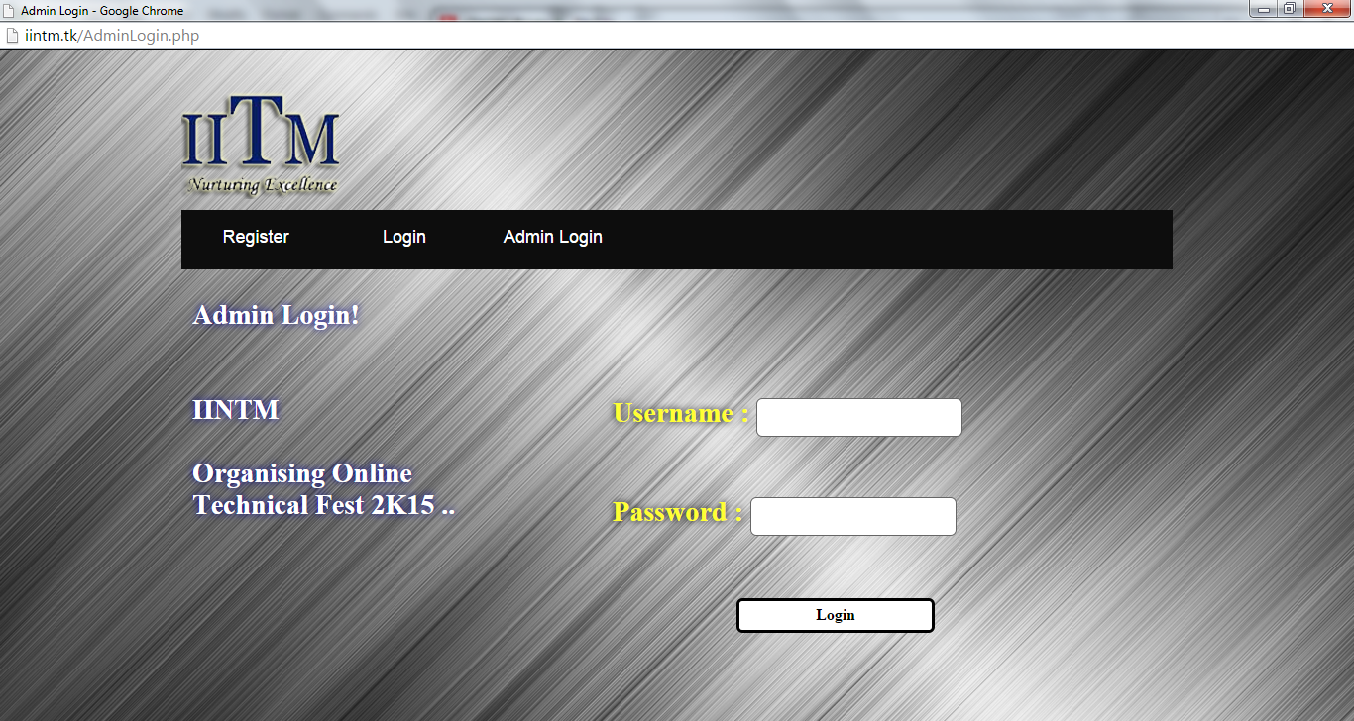

**Screenshot 4.14: Admin Login Page**

* 1. **AdminManageHome.php**

<?php @session_start(); ?>

<?php require_once('Connections/mysql.php'); ?>

<?php

if (!function_exists("GetSQLValueString")) {

function GetSQLValueString($theValue, $theType, $theDefinedValue = "", $theNotDefinedValue = "")

{

if (PHP_VERSION < 6) {

$theValue = get_magic_quotes_gpc() ? stripslashes($theValue) : $theValue;

}

$theValue = function_exists("mysql_real_escape_string") ? mysql_real_escape_string($theValue) : mysql_escape_string($theValue);

switch ($theType) {

case "text":

$theValue = ($theValue != "") ? "'" . $theValue . "'" : "NULL";

break;

case "long":

case "int":

$theValue = ($theValue != "") ? intval($theValue) : "NULL";

break;

case "double":

$theValue = ($theValue != "") ? doubleval($theValue) : "NULL";

break;

case "date":

$theValue = ($theValue != "") ? "'" . $theValue . "'" : "NULL";

break;

case "defined":

$theValue = ($theValue != "") ? $theDefinedValue : $theNotDefinedValue;

break;

}

return $theValue;

}

}

$colname_AdminHome = "-1";

if (isset($_SESSION['MM_Username'])) {

$colname_AdminHome = $_SESSION['MM_Username'];

}

mysql_select_db($database_mysql, $mysql);

$query_AdminHome = sprintf("SELECT * FROM `admin` WHERE Username = %s", GetSQLValueString($colname_AdminHome, "text"));

$AdminHome = mysql_query($query_AdminHome, $mysql) or die(mysql_error());

$row_AdminHome = mysql_fetch_assoc($AdminHome);

$totalRows_AdminHome = mysql_num_rows($AdminHome);$colname_AdminHome = "-1";

if (isset($_SESSION['MM_Username'])) {

$colname_AdminHome = $_SESSION['MM_Username'];

}

@session_start(); ?>

<?php

$currentPage = $_SERVER["PHP_SELF"];

$queryString_ManageUsers = "";

if (!empty($_SERVER['QUERY_STRING'])) {

$params = explode("&", $_SERVER['QUERY_STRING']);

$newParams = array();

foreach ($params as $param) {

if (stristr($param, "pageNum_ManageUsers") == false &&

stristr($param, "totalRows_ManageUsers") == false) {

array_push($newParams, $param);

}

}

if (count($newParams) != 0) {

$queryString_ManageUsers = "&" . htmlentities(implode("&", $newParams));

}

}

?>

<!DOCTYPE html PUBLIC "-//W3C//DTD XHTML 1.0 Transitional//EN" "http://www.w3.org/TR/xhtml1/DTD/xhtml1-transitional.dtd">

<html xmlns="http://www.w3.org/1999/xhtml">

<head>

<link href="CSS/Layout.css" rel="stylesheet" type="text/css"/>

<link href="CSS/Menu.css" rel="stylesheet" type="text/css"/>

<meta http-equiv="Content-Type" content="text/html; charset=utf-8" />

<title>Admin</title>

</head>

<body>

<div id="Holder">

<div id="Header"></div>

<div id="NavBar">

<nav>

<ul>

<li><a href="AdminManageHome.php">Home</a></li>

<li><a href="ViewUsers.php">View Users</a></li>

<li><a href="AdminManage.php">Manage Account</a></li> <li><a href="EventResult.php">Result</a></li>

<li><a href="LogOut.php">Logout</a></li>

</ul> </nav></div>

<div id="Content">

<div id="PageHeading">

<h1 id="Text2">Hi ,<?php echo $row_AdminHome['Username']; ?> !</h1>

</div><div id="ContentLeft"></div>

<div id="ContentRight"> <form id="Form" name="Form" method="post" action="">

<table width="670" border="0" align="center">

<tr>

<td align="center" valign="middle"><h1 id="Text3">WELCOME....!!!</h1></td>

</tr>

</table></form>

</div></div><div id="Footer"></div></div>

</body>

</html>

<?php

mysql_free_result($AdminHome);

?>

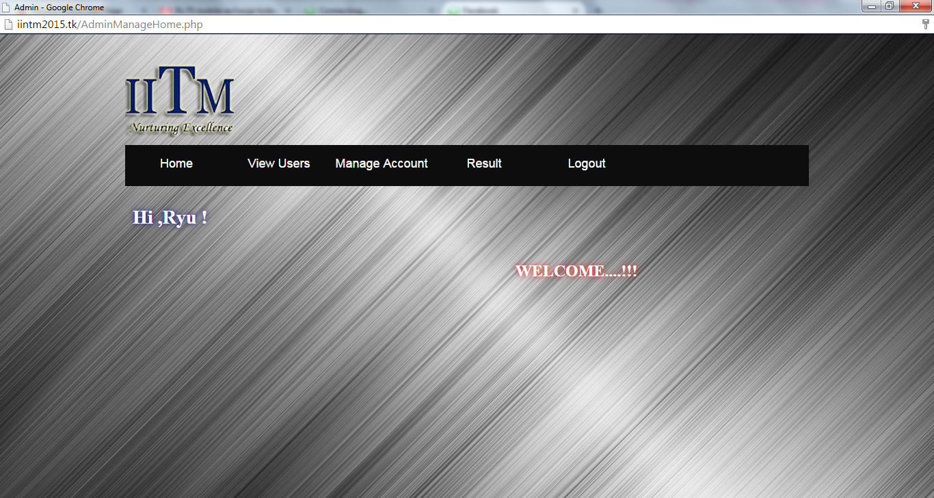

**Screenshot 4.15: Admin Home Page**

* 1. **ViewUsers.php**

<?php require_once('Connections/mysql.php'); ?>

<?php

@session_start();

if (!function_exists("GetSQLValueString")) {

function GetSQLValueString($theValue, $theType, $theDefinedValue = "", $theNotDefinedValue = "")

{

if (PHP_VERSION < 6) {

$theValue = get_magic_quotes_gpc() ? stripslashes($theValue) : $theValue;

}

$theValue = function_exists("mysql_real_escape_string") ? mysql_real_escape_string($theValue) : mysql_escape_string($theValue);

switch ($theType) {

case "text":

$theValue = ($theValue != "") ? "'" . $theValue . "'" : "NULL";

break;

case "long":

case "int":

$theValue = ($theValue != "") ? intval($theValue) : "NULL";

break;

case "double":

$theValue = ($theValue != "") ? doubleval($theValue) : "NULL";

break;

case "date":

$theValue = ($theValue != "") ? "'" . $theValue . "'" : "NULL";

break;

case "defined":

$theValue = ($theValue != "") ? $theDefinedValue : $theNotDefinedValue;

break;

}

return $theValue;

}

}

$colname_AdminHome = "-1";

if (isset($_SESSION['MM_Username'])) {

$colname_AdminHome = $_SESSION['MM_Username'];

}

mysql_select_db($database_mysql, $mysql);

$query_AdminHome = sprintf("SELECT * FROM `admin` WHERE Username = %s", GetSQLValueString($colname_AdminHome, "text"));

$AdminHome = mysql_query($query_AdminHome, $mysql) or die(mysql_error());

$row_AdminHome = mysql_fetch_assoc($AdminHome);

$totalRows_AdminHome = mysql_num_rows($AdminHome);

if(isset($_POST["submit"]))

{

$View = $_POST['View'];

if($View == 'ARTI')

{

header('Location: ViewArti.php');

}elseif($View == 'SPIDER')

{

header('Location: ViewSpider.php');

}elseif($View == 'DEBUG')

{

header('Location: ViewDebug.php');

}

elseif($View == 'X-COMWAR')

{

header('Location: ViewXComwar.php');

}

}

?>

<!DOCTYPE html PUBLIC "-//W3C//DTD XHTML 1.0 Transitional//EN" "http://www.w3.org/TR/xhtml1/DTD/xhtml1-transitional.dtd">

<html xmlns="http://www.w3.org/1999/xhtml">

<head>

<link href="CSS/Layout.css" rel="stylesheet" type="text/css"/>

<link href="CSS/Menu.css" rel="stylesheet" type="text/css"/>

<meta http-equiv="Content-Type" content="text/html; charset=utf-8" />

<title>View Users</title>

</head>

<body>

<div id="Holder">

<div id="Header"></div>

<div id="NavBar">

<nav>

<ul>

<li><a href="AdminManageHome.php">Home</a></li>

<li><a href="ViewUsers.php">View Users</a></li>

<li><a href="AdminManage.php">Manage Account</a></li>

<li><a href="EventResult.php">Result</a></li>

<li><a href="LogOut.php">Logout</a></li>

</ul>

</nav>

</div>

<div id="Content">

<div id="PageHeading">

<h1 id="Text2">Hi, <?php echo $row_AdminHome['Username']; ?></h1>

</div>

<div id="ContentLeft">

</div>

<div id="ContentRight">

<form id="View" name="View" method="post" action="" >

<table width="500" align="center" id="Text4">

<tr>

<td><input type="radio" name="View" id="View" value="ARTI" />

<label for="ARTI"> ARTI-CODE</label></td>

</tr>

<tr>

<td>&nbsp;</td>

</tr>

<tr>

<td><input type="radio" name="View" id="View" value="SPIDER" />

<label for="SPIDER"> SPIDERWICK</label></td>

</tr>

<tr>

<td>&nbsp;</td>

</tr>

<tr>

<td><input type="radio" name="View" id="View" value="DEBUG" />

<label for="DEBUG"> BUG 2 DEBUG</label></td>

</tr>

<tr>

<td>&nbsp;</td>

</tr>

<tr> <td><input type="radio" name="View" id="View" value="X-COMWAR" />

<label for="X-COMWAR">X-COMWAR</label></td>

</tr> <tr> <td>&nbsp;</td> </tr>

<tr> <td><input type="hidden" name="ViewResult" id="ViewResult" /></td>

</tr> <tr>

<td><center><input name="submit" type="submit" class="StyleTextField" id="View Users" value="View Users" /></center></td>

</tr> </table> </form>

</div></div>

<div id="Footer"></div>

</div>

</body>

</html>

<?php mysql_free_result($AdminHome); ?>

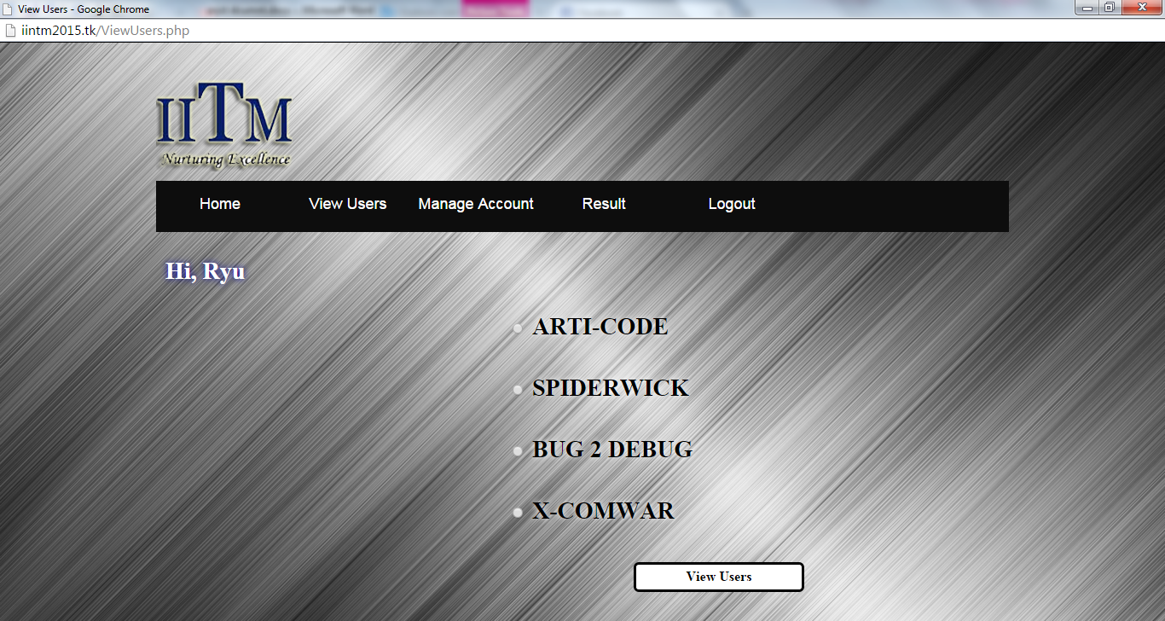

**Screenshot 4.16: View Users Page**

* 1. **ViewArti.php**

<?php @session_start(); ?>

<?php require_once('Connections/mysql.php'); ?>

<?php

if (!function_exists("GetSQLValueString")) {

function GetSQLValueString($theValue, $theType, $theDefinedValue = "", $theNotDefinedValue = "")

{

if (PHP_VERSION < 6) {

$theValue = get_magic_quotes_gpc() ? stripslashes($theValue) : $theValue;

}

$theValue = function_exists("mysql_real_escape_string") ? mysql_real_escape_string($theValue) : mysql_escape_string($theValue);

switch ($theType) {

case "text":

$theValue = ($theValue != "") ? "'" . $theValue . "'" : "NULL";

break;

case "long":

case "int":

$theValue = ($theValue != "") ? intval($theValue) : "NULL";

break;

case "double":

$theValue = ($theValue != "") ? doubleval($theValue) : "NULL";

break;

case "date":

$theValue = ($theValue != "") ? "'" . $theValue . "'" : "NULL";

break;

case "defined":

$theValue = ($theValue != "") ? $theDefinedValue : $theNotDefinedValue;

break;

}

return $theValue;

}

}

$currentPage = $_SERVER["PHP_SELF"];

if (!function_exists("GetSQLValueString")) {

function GetSQLValueString($theValue, $theType, $theDefinedValue = "", $theNotDefinedValue = "")

{

if (PHP_VERSION < 6) {

$theValue = get_magic_quotes_gpc() ? stripslashes($theValue) : $theValue;

}

$theValue = function_exists("mysql_real_escape_string") ? mysql_real_escape_string($theValue) : mysql_escape_string($theValue);

switch ($theType) {

case "text":

$theValue = ($theValue != "") ? "'" . $theValue . "'" : "NULL";

break;

case "long":

case "int":

$theValue = ($theValue != "") ? intval($theValue) : "NULL";

break;

case "double":

$theValue = ($theValue != "") ? doubleval($theValue) : "NULL";

break;

case "date":

$theValue = ($theValue != "") ? "'" . $theValue . "'" : "NULL";

break;

case "defined":

$theValue = ($theValue != "") ? $theDefinedValue : $theNotDefinedValue;

break;

}

return $theValue;

}

}

$colname_User = "-1";

if (isset($_SESSION['MM_Username'])) {

$colname_User = $_SESSION['MM_Username'];

}

mysql_select_db($database_mysql, $mysql);

$query_User = sprintf("SELECT * FROM `admin` WHERE Username = %s", GetSQLValueString($colname_User, "text"));

$User = mysql_query($query_User, $mysql) or die(mysql_error());

$row_User = mysql_fetch_assoc($User);

$totalRows_User = mysql_num_rows($User);

$maxRows_ManageUsers = 100;

$pageNum_ManageUsers = 0;

if (isset($_GET['pageNum_ManageUsers'])) {

$pageNum_ManageUsers = $_GET['pageNum_ManageUsers'];

}

$startRow_ManageUsers = $pageNum_ManageUsers * $maxRows_ManageUsers;

mysql_select_db($database_mysql, $mysql);

$query_ManageUsers = "SELECT * FROM register WHERE register.Event = 'ARTI-CODE'";

$query_limit_ManageUsers = sprintf("%s LIMIT %d, %d", $query_ManageUsers, $startRow_ManageUsers, $maxRows_ManageUsers);

$ManageUsers = mysql_query($query_limit_ManageUsers, $mysql) or die(mysql_error());

$row_ManageUsers = mysql_fetch_assoc($ManageUsers);

if (isset($_GET['totalRows_ManageUsers'])) {

$totalRows_ManageUsers = $_GET['totalRows_ManageUsers'];

} else {

$all_ManageUsers = mysql_query($query_ManageUsers);

$totalRows_ManageUsers = mysql_num_rows($all_ManageUsers);

}

$totalPages_ManageUsers = ceil($totalRows_ManageUsers/$maxRows_ManageUsers)-1;

$queryString_ManageUsers = "";

if (!empty($_SERVER['QUERY_STRING'])) {

$params = explode("&", $_SERVER['QUERY_STRING']);

$newParams = array();

foreach ($params as $param) {

if (stristr($param, "pageNum_ManageUsers") == false &&

stristr($param, "totalRows_ManageUsers") == false) {

array_push($newParams, $param);

}

}

if (count($newParams) != 0) {

$queryString_ManageUsers = "&" . htmlentities(implode("&", $newParams));

}

}

$queryString_ManageUsers = sprintf("&totalRows_ManageUsers=%d%s", $totalRows_ManageUsers, $queryString_ManageUsers);

?>

<!DOCTYPE html PUBLIC "-//W3C//DTD XHTML 1.0 Transitional//EN" "http://www.w3.org/TR/xhtml1/DTD/xhtml1-transitional.dtd">

<html xmlns="http://www.w3.org/1999/xhtml">

<head>

<link href="CSS/Layout.css" rel="stylesheet" type="text/css"/>

<link href="CSS/Menu.css" rel="stylesheet" type="text/css"/>

<meta http-equiv="Content-Type" content="text/html; charset=utf-8" />

<title>View Arti-CODE</title>

</head>

<body>

<div id="Holder">

<div id="Header"></div>

<div id="NavBar">

<nav>

<ul>

<li><a href="AdminManageHome.php">Home</a></li>

<li><a href="ViewUsers.php">View Users</a></li>

<li><a href="AdminManage.php">Manage Account</a></li>

<li><a href="EventResult.php">Result</a></li>

<li><a href="LogOut.php">Logout</a></li>

</ul>

</nav>

</div>

<div id="Content">

<div id="PageHeading">

<h1 id="Text2">Hi, <?php echo $row_User['Username']; ?>!</h1>

</div>

<div id="ContentLeft">

</div>

<div id="ContentRight">

<form id="Form" name="Form" method="post" action="">

<table width="670" border="0" align="center">

<tr>

<td height="31" align="right" valign="top"><pre>Showing: <?php echo ($startRow_ManageUsers + 1) ?> To : <?php echo min($startRow_ManageUsers + $maxRows_ManageUsers, $totalRows_ManageUsers) ?> Of :<?php echo $totalRows_ManageUsers ?>

</pre></td>

</tr>

<tr>

<td valign="top">

<table width="747" bgcolor="#CCCCCC" align="left">

<tr>

<td width="243">Full Name</td>

<td width="241">Mobile</td>

<td width="241">Email</td>

</tr>

</table>

</br>

<?php do { ?>

<table width="747" bgcolor="#CCCCCC" align="left">

<tr>

<td width="243"><?php echo $row_ManageUsers['Fname']; ?> <?php echo $row_ManageUsers['Lname']; ?></td>

<td width="241"><?php echo $row_ManageUsers['Mob']; ?></td>

<td width="241"><?php echo $row_ManageUsers['Email']; ?></td>

</tr>

</table>

<?php } while ($row_ManageUsers = mysql_fetch_assoc($ManageUsers)); ?>

</center></td>

</tr>

<tr> </tr>

</table>

<center></br></br>

<input name="Print" type="button" class="StyleTextField" onClick="window.print()" value="Print" /></center>

</form>

</div></div><div id="Footer"></div></div>

</body>

</html>

<?php

mysql_free_result($User);

mysql_free_result($ManageUsers);

?>

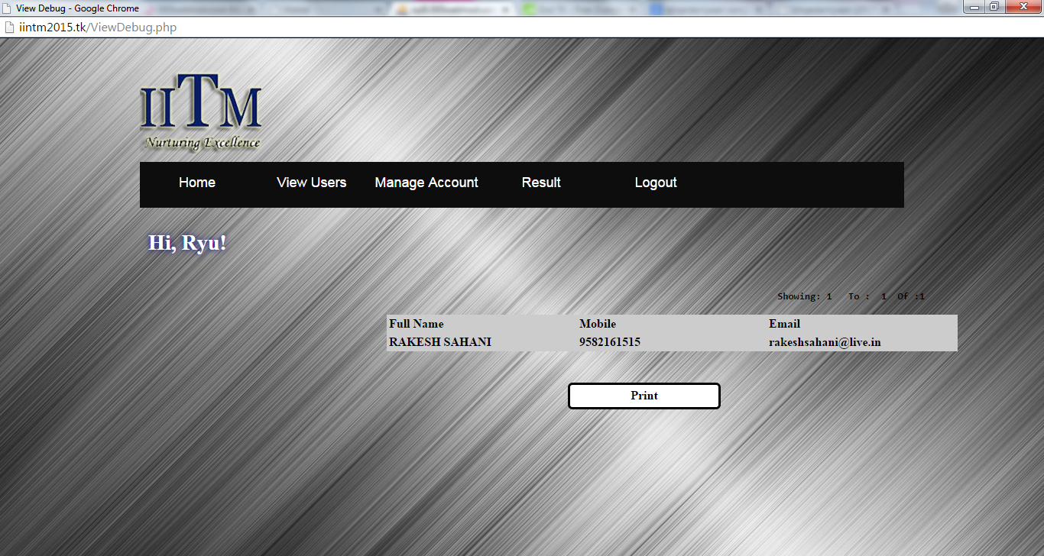

**Screenshot 4.17: View Event Registered User Page**

* 1. **AdminManage.php**

<?php @session_start(); ?>

<?php require_once('Connections/mysql.php'); ?>

<?php

if (!function_exists("GetSQLValueString")) {

function GetSQLValueString($theValue, $theType, $theDefinedValue = "", $theNotDefinedValue = "")

{

if (PHP_VERSION < 6) {

$theValue = get_magic_quotes_gpc() ? stripslashes($theValue) : $theValue;

}

$theValue = function_exists("mysql_real_escape_string") ? mysql_real_escape_string($theValue) : mysql_escape_string($theValue);

switch ($theType) {

case "text":

$theValue = ($theValue != "") ? "'" . $theValue . "'" : "NULL";

break;

case "long":

case "int":

$theValue = ($theValue != "") ? intval($theValue) : "NULL";

break;

case "double":

$theValue = ($theValue != "") ? doubleval($theValue) : "NULL";

break;

case "date":

$theValue = ($theValue != "") ? "'" . $theValue . "'" : "NULL";

break;

case "defined":

$theValue = ($theValue != "") ? $theDefinedValue : $theNotDefinedValue;

break;

}

return $theValue;

}

}

$currentPage = $_SERVER["PHP_SELF"];

if ((isset($_POST['DeletehiddenField'])) && ($_POST['DeletehiddenField'] != "")) {

$deleteSQL = sprintf("DELETE FROM register WHERE UserID=%s",

GetSQLValueString($_POST['DeletehiddenField'], "int"));

mysql_select_db($database_mysql, $mysql);

$Result1 = mysql_query($deleteSQL, $mysql) or die(mysql_error());

$deleteGoTo = "AccountDelete.php";

if (isset($_SERVER['QUERY_STRING'])) {

$deleteGoTo .= (strpos($deleteGoTo, '?')) ? "&" : "?";

$deleteGoTo .= $_SERVER['QUERY_STRING'];

}

header(sprintf("Location: %s", $deleteGoTo));

}

if (!function_exists("GetSQLValueString")) {

function GetSQLValueString($theValue, $theType, $theDefinedValue = "", $theNotDefinedValue = "")

{

if (PHP_VERSION < 6) {

$theValue = get_magic_quotes_gpc() ? stripslashes($theValue) : $theValue;

}

$theValue = function_exists("mysql_real_escape_string") ? mysql_real_escape_string($theValue) : mysql_escape_string($theValue);

switch ($theType) {

case "text":

$theValue = ($theValue != "") ? "'" . $theValue . "'" : "NULL";

break;

case "long":

case "int":

$theValue = ($theValue != "") ? intval($theValue) : "NULL";

break;

case "double":

$theValue = ($theValue != "") ? doubleval($theValue) : "NULL";

break;

case "date":

$theValue = ($theValue != "") ? "'" . $theValue . "'" : "NULL";

break;

case "defined":

$theValue = ($theValue != "") ? $theDefinedValue : $theNotDefinedValue;

break;

}

return $theValue;

}

}

$colname_User = "-1";

if (isset($_SESSION['MM_Username'])) {

$colname_User = $_SESSION['MM_Username'];

}

mysql_select_db($database_mysql, $mysql);

$query_User = sprintf("SELECT * FROM `admin` WHERE Username = %s", GetSQLValueString($colname_User, "text"));

$User = mysql_query($query_User, $mysql) or die(mysql_error());

$row_User = mysql_fetch_assoc($User);

$totalRows_User = mysql_num_rows($User);

$maxRows_ManageUsers = 10;

$pageNum_ManageUsers = 0;

if (isset($_GET['pageNum_ManageUsers'])) {

$pageNum_ManageUsers = $_GET['pageNum_ManageUsers'];

}

$startRow_ManageUsers = $pageNum_ManageUsers * $maxRows_ManageUsers;

mysql_select_db($database_mysql, $mysql);

$query_ManageUsers = "SELECT * FROM register ORDER BY `Timestamp` DESC";

$query_limit_ManageUsers = sprintf("%s LIMIT %d, %d", $query_ManageUsers, $startRow_ManageUsers, $maxRows_ManageUsers);

$ManageUsers = mysql_query($query_limit_ManageUsers, $mysql) or die(mysql_error());

$row_ManageUsers = mysql_fetch_assoc($ManageUsers);

if (isset($_GET['totalRows_ManageUsers'])) {

$totalRows_ManageUsers = $_GET['totalRows_ManageUsers'];

} else {

$all_ManageUsers = mysql_query($query_ManageUsers);

$totalRows_ManageUsers = mysql_num_rows($all_ManageUsers);

}

$totalPages_ManageUsers = ceil($totalRows_ManageUsers/$maxRows_ManageUsers)-1;

$queryString_ManageUsers = "";

if (!empty($_SERVER['QUERY_STRING'])) {

$params = explode("&", $_SERVER['QUERY_STRING']);

$newParams = array();

foreach ($params as $param) {

if (stristr($param, "pageNum_ManageUsers") == false &&

stristr($param, "totalRows_ManageUsers") == false) {

array_push($newParams, $param);

}

}

if (count($newParams) != 0) {

$queryString_ManageUsers = "&" . htmlentities(implode("&", $newParams));

}

}

$queryString_ManageUsers = sprintf("&totalRows_ManageUsers=%d%s", $totalRows_ManageUsers, $queryString_ManageUsers);

?>

<!DOCTYPE html PUBLIC "-//W3C//DTD XHTML 1.0 Transitional//EN" "http://www.w3.org/TR/xhtml1/DTD/xhtml1-transitional.dtd">

<html xmlns="http://www.w3.org/1999/xhtml">

<head>

<link href="CSS/Layout.css" rel="stylesheet" type="text/css"/>

<link href="CSS/Menu.css" rel="stylesheet" type="text/css"/>

<meta http-equiv="Content-Type" content="text/html; charset=utf-8" />

<title>Manage Account</title>

</head>

<body>

<div id="Holder">

<div id="Header"></div>

<div id="NavBar">

<nav>

<ul>

<li><a href="AdminManageHome.php">Home</a></li>

<li><a href="ViewUsers.php">View Users</a></li>

<li><a href="AdminManage.php">Manage Account</a></li>

<li><a href="EventResult.php">Result</a></li>

<li><a href="LogOut.php">Logout</a></li>

</ul>

</nav>

</div>

<div id="Content">

<div id="PageHeading">

<h1 id="Text2">Hi , <?php echo $row_User['Username']; ?> !</h1>

</div>

<div id="ContentLeft">

</div>

<div id="ContentRight">

<form id="DeleteForm" name="DeleteForm" method="post" action="">

<table width="670" align="center">

<tr>

<td height="31" align="right" valign="top"><pre>Showing:<?php echo ($startRow_ManageUsers + 1) ?> To:<?php echo min($startRow_ManageUsers + $maxRows_ManageUsers, $totalRows_ManageUsers) ?> Of:<?php echo $totalRows_ManageUsers ?>

</pre></td>

</tr>

<tr>

<td align="center" valign="top"><?php if ($totalRows_ManageUsers > 0) { // Show if recordset not empty ?>

<?php do { ?>

<table width="583" border="1" align="left" bgcolor="#CCCCCC">

<tr align="center">

<h3>

<td>First Name </td>

<td>Last Name </td>

<td>Email</td>

<td>Delete</td>

</h3>

</tr>

<tr align="center">

<h3>

<td><?php echo $row_ManageUsers['Fname']; ?></td>

<td><?php echo $row_ManageUsers['Lname']; ?></td>

<td><?php echo $row_ManageUsers['Email']; ?></td>

</h3>

<td rowspan="2" align="center"><input name="DeletehiddenField" type="hidden" id="DeletehiddenField" value="<?php echo $row_ManageUsers['UserID']; ?>" />

<input type="submit" name="DeleteUsers" id="DeleteUsers" value="Delete User" /></td>

</tr>

</table>

<?php } while ($row_ManageUsers = mysql_fetch_assoc($ManageUsers)); ?>

<?php } // Show if recordset not empty ?></td>

</tr>

<tr>

<td align="center" valign="top"><h2> <a href="<?php printf("%s?pageNum_ManageUsers=%d%s", $currentPage, min($totalPages_ManageUsers, $pageNum_ManageUsers + 1), $queryString_ManageUsers); ?>">Next</a>&nbsp;&nbsp;&nbsp;&nbsp; <a href="<?php printf("%s?pageNum_ManageUsers=%d%s", $currentPage, $totalPages_ManageUsers, $queryString_ManageUsers); ?>">Previous</a></h2></td>

</tr>

</table></td>

</tr>

<tr>

</table></form>

</div>

</div>

<div id="Footer"></div>

</div>

</body>

</html>

<?php

mysql_free_result($User);

mysql_free_result($ManageUsers);

?>

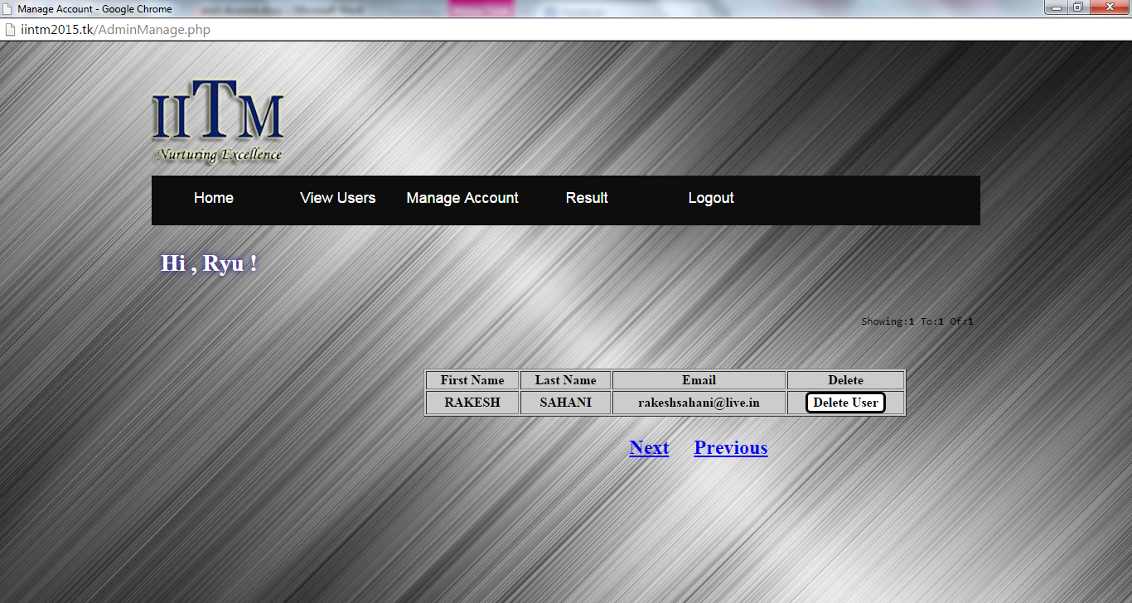

**Screenshot 4.18: Account Manage Page**

.

* 1. **AccountDelete.php**

<?php @session_start(); ?>

<?php require_once('Connections/mysql.php'); ?>

<?php

if (!function_exists("GetSQLValueString")) {

function GetSQLValueString($theValue, $theType, $theDefinedValue = "", $theNotDefinedValue = "")

{

if (PHP_VERSION < 6) {

$theValue = get_magic_quotes_gpc() ? stripslashes($theValue) : $theValue;

}

$theValue = function_exists("mysql_real_escape_string") ? mysql_real_escape_string($theValue) : mysql_escape_string($theValue);

switch ($theType) {

case "text":

$theValue = ($theValue != "") ? "'" . $theValue . "'" : "NULL";

break;

case "long":

case "int":

$theValue = ($theValue != "") ? intval($theValue) : "NULL";

break;

case "double":

$theValue = ($theValue != "") ? doubleval($theValue) : "NULL";

break;

case "date":

$theValue = ($theValue != "") ? "'" . $theValue . "'" : "NULL";

break;

case "defined":

$theValue = ($theValue != "") ? $theDefinedValue : $theNotDefinedValue;

break;

}

return $theValue;

}

}

$colname_AdminHome = "-1";

if (isset($_SESSION['MM_Username'])) {

$colname_AdminHome = $_SESSION['MM_Username'];

}

mysql_select_db($database_mysql, $mysql);

$query_AdminHome = sprintf("SELECT * FROM `admin` WHERE Username = %s", GetSQLValueString($colname_AdminHome, "text"));

$AdminHome = mysql_query($query_AdminHome, $mysql) or die(mysql_error());

$row_AdminHome = mysql_fetch_assoc($AdminHome);

$totalRows_AdminHome = mysql_num_rows($AdminHome);

@session_start(); ?>

<?php

$currentPage = $_SERVER["PHP_SELF"];

$queryString_ManageUsers = "";

if (!empty($_SERVER['QUERY_STRING'])) {

$params = explode("&", $_SERVER['QUERY_STRING']);

$newParams = array();

foreach ($params as $param) {

if (stristr($param, "pageNum_ManageUsers") == false &&

stristr($param, "totalRows_ManageUsers") == false) {

array_push($newParams, $param);

}

}

if (count($newParams) != 0) {

$queryString_ManageUsers = "&" . htmlentities(implode("&", $newParams));

}

}

?>

<!DOCTYPE html PUBLIC "-//W3C//DTD XHTML 1.0 Transitional//EN" "http://www.w3.org/TR/xhtml1/DTD/xhtml1-transitional.dtd">

<html xmlns="http://www.w3.org/1999/xhtml">

<head>

<link href="CSS/Layout.css" rel="stylesheet" type="text/css"/>

<link href="CSS/Menu.css" rel="stylesheet" type="text/css"/>

<meta http-equiv="Content-Type" content="text/html; charset=utf-8" />

<title>Account Delete</title>

</head>

<body>

<div id="Holder">

<div id="Header"></div>

<div id="NavBar">

<nav>

<ul>

<li><a href="AdminManageHome.php">Home</a></li>

<li><a href="ViewUsers.php">View Users</a></li>

<li><a href="AdminManage.php">Manage Account</a></li>

<li><a href="EventResult.php">Result</a></li>

<li><a href="LogOut.php">Logout</a></li>

</ul>

</nav>

</div>

<div id="Content">

<div id="PageHeading">

<h1 id="Text3">Successfully Deleted.... !!!</h1>

<?php header( "refresh:3;url=AdminManageHome.php" ); ?>

</div>

<div id="ContentLeft">

</div>

<div id="ContentRight">

</div></div>

<div id="Footer"></div>

</div>

</body>

</html>

<?php

mysql_free_result($AdminHome);

?>



**Screenshot 4.19: Success Page**

* 1. **EventResult.php**

<?php @session_start(); ?>

<?php require_once('Connections/mysql.php'); ?>

<?php

if (!function_exists("GetSQLValueString")) {

function GetSQLValueString($theValue, $theType, $theDefinedValue = "", $theNotDefinedValue = "")

{

if (PHP_VERSION < 6) {

$theValue = get_magic_quotes_gpc() ? stripslashes($theValue) : $theValue;

}

$theValue = function_exists("mysql_real_escape_string") ? mysql_real_escape_string($theValue) : mysql_escape_string($theValue);

switch ($theType) {

case "text":

$theValue = ($theValue != "") ? "'" . $theValue . "'" : "NULL";

break;

case "long":

case "int":

$theValue = ($theValue != "") ? intval($theValue) : "NULL";

break;

case "double":

$theValue = ($theValue != "") ? doubleval($theValue) : "NULL";

break;

case "date":

$theValue = ($theValue != "") ? "'" . $theValue . "'" : "NULL";

break;

case "defined":

$theValue = ($theValue != "") ? $theDefinedValue : $theNotDefinedValue;

break;

}

return $theValue;

}

}

$colname_User = "-1";

if (isset($_GET['MM_Username'])) {

$colname_User = $_GET['MM_Username'];

}

mysql_select_db($database_mysql, $mysql);

$query_User = sprintf("SELECT * FROM register WHERE Username = %s", GetSQLValueString($colname_User, "text"));

$User = mysql_query($query_User, $mysql) or die(mysql_error());

$row_User = mysql_fetch_assoc($User);

$totalRows_User = mysql_num_rows($User);

$colname_AdminHome = "-1";

if (isset($_SESSION['MM_Username'])) {

$colname_AdminHome = $_SESSION['MM_Username'];

}

mysql_select_db($database_mysql, $mysql);

$query_AdminHome = sprintf("SELECT * FROM `admin` WHERE Username = %s", GetSQLValueString($colname_AdminHome, "text"));

$AdminHome = mysql_query($query_AdminHome, $mysql) or die(mysql_error());

$row_AdminHome = mysql_fetch_assoc($AdminHome);

$totalRows_AdminHome = mysql_num_rows($AdminHome);

?>

<?php

if(isset($_POST["submit"]))

{

$View = $_POST['View'];

if($View == 'ARTI')

{

header('Location: ArtiResult.php');

}elseif($View == 'SPIDER')

{

header('Location: SpiderResult.php');

}elseif($View == 'DEBUG')

{

header('Location: DebugResult.php');

}

}

?>

<!DOCTYPE html PUBLIC "-//W3C//DTD XHTML 1.0 Transitional//EN" "http://www.w3.org/TR/xhtml1/DTD/xhtml1-transitional.dtd">

<html xmlns="http://www.w3.org/1999/xhtml">

<head>

<link href="CSS/Layout.css" rel="stylesheet" type="text/css"/>

<link href="CSS/Menu.css" rel="stylesheet" type="text/css"/>

<meta http-equiv="Content-Type" content="text/html; charset=utf-8" />

<title>View Event Results</title>

</head>

<body>

<div id="Holder">

<div id="Header"></div>

<div id="NavBar">

<nav>

<ul>

<li><a href="AdminManageHome.php">Home</a></li>

<li><a href="ViewUsers.php">View Users</a></li>

<li><a href="AdminManage.php">Manage Account</a></li>

<li><a href="EventResult.php">Result</a></li>

<li><a href="LogOut.php">Logout</a></li>

</ul>

</nav>

</div>

<div id="Content">

<div id="PageHeading">

<h1 id="Text2">Hi ,<?php echo $row_AdminHome['Username']; ?></h1>

</div>

<div id="ContentLeft">

</div>

<div id="ContentRight">

<form id="Result" name="Result" method="post" action="">

<table width="500" align="center" id="Text4">

<tr>

<td><input type="radio" name="View" id="View" value="ARTI" />

<label for="ARTI"> ARTI-CODE</label></td>

</tr>

<tr>

<td>&nbsp;</td>

</tr>

<tr>

<td><input type="radio" name="View" id="View" value="SPIDER" />

<label for="SPIDER"> SPIDERWICK</label></td>

</tr>

<tr> <td>&nbsp;</td> </tr>

<tr>

<td><input type="radio" name="View" id="View" value="DEBUG" />

<label for="DEBUG"> BUG 2 DEBUG</label></td>

</tr> <tr> <td>&nbsp;</td> </tr>

<tr> <td><input type="hidden" name="ViewResult" id="ViewResult" /></td> </tr>

<tr>

<td><center><input name="submit" type="submit" class="StyleTextField" id="View Result" value="View Result" /></center></td>

</tr>

</table> </form> </div></div><div id="Footer"></div></div>

</body>

</html>

<?php

mysql_free_result($User);

mysql_free_result($AdminHome);

?>

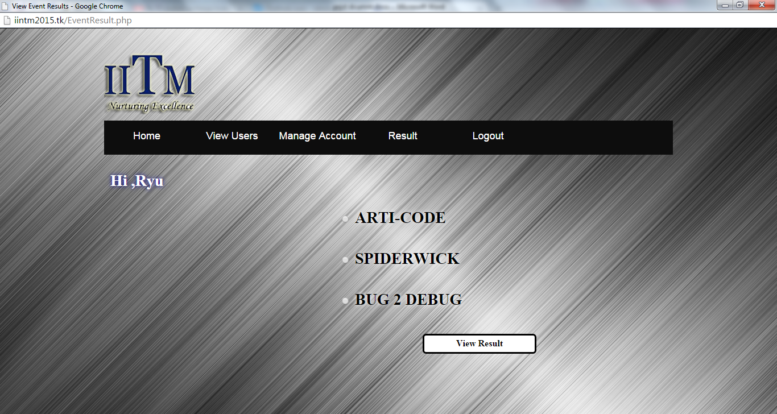

**Screenshot 4.20: View Event Result Page**

* 1. **ArtiResult.php**

<?php @session_start(); ?>

<?php require_once('Connections/mysql.php'); ?>

<?php

if (!function_exists("GetSQLValueString")) {

function GetSQLValueString($theValue, $theType, $theDefinedValue = "", $theNotDefinedValue = "")

{

if (PHP_VERSION < 6) {

$theValue = get_magic_quotes_gpc() ? stripslashes($theValue) : $theValue;

}

$theValue = function_exists("mysql_real_escape_string") ? mysql_real_escape_string($theValue) : mysql_escape_string($theValue);

switch ($theType) {

case "text":

$theValue = ($theValue != "") ? "'" . $theValue . "'" : "NULL";

break;

case "long":

case "int":

$theValue = ($theValue != "") ? intval($theValue) : "NULL";

break;

case "double":

$theValue = ($theValue != "") ? doubleval($theValue) : "NULL";

break;

case "date":

$theValue = ($theValue != "") ? "'" . $theValue . "'" : "NULL";

break;

case "defined":

$theValue = ($theValue != "") ? $theDefinedValue : $theNotDefinedValue;

break;

}

return $theValue;

}

}

$currentPage = $_SERVER["PHP_SELF"];

if (!function_exists("GetSQLValueString")) {

function GetSQLValueString($theValue, $theType, $theDefinedValue = "", $theNotDefinedValue = "")

{

if (PHP_VERSION < 6) {

$theValue = get_magic_quotes_gpc() ? stripslashes($theValue) : $theValue;

}

$theValue = function_exists("mysql_real_escape_string") ? mysql_real_escape_string($theValue) : mysql_escape_string($theValue);

switch ($theType) {

case "text":

$theValue = ($theValue != "") ? "'" . $theValue . "'" : "NULL";

break;

case "long":

case "int":

$theValue = ($theValue != "") ? intval($theValue) : "NULL";

break;

case "double":

$theValue = ($theValue != "") ? doubleval($theValue) : "NULL";

break;

case "date":

$theValue = ($theValue != "") ? "'" . $theValue . "'" : "NULL";

break;

case "defined":

$theValue = ($theValue != "") ? $theDefinedValue : $theNotDefinedValue;

break;

}

return $theValue;

}

}

$colname_User = "-1";

if (isset($_SESSION['MM_Username'])) {

$colname_User = $_SESSION['MM_Username'];

}

mysql_select_db($database_mysql, $mysql);

$query_User = sprintf("SELECT * FROM `admin` WHERE Username = %s", GetSQLValueString($colname_User, "text"));

$User = mysql_query($query_User, $mysql) or die(mysql_error());

$row_User = mysql_fetch_assoc($User);

$totalRows_User = mysql_num_rows($User);

$maxRows_ManageUsers = 5;

$pageNum_ManageUsers = 0;

if (isset($_GET['pageNum_ManageUsers'])) {

$pageNum_ManageUsers = $_GET['pageNum_ManageUsers'];

}

$startRow_ManageUsers = $pageNum_ManageUsers * $maxRows_ManageUsers;

mysql_select_db($database_mysql, $mysql);

$query_ManageUsers = "SELECT * FROM `result` WHERE `result`.Event_Name = ' ARTI-CODE'";

$query_limit_ManageUsers = sprintf("%s LIMIT %d, %d", $query_ManageUsers, $startRow_ManageUsers, $maxRows_ManageUsers);

$ManageUsers = mysql_query($query_limit_ManageUsers, $mysql) or die(mysql_error());

$row_ManageUsers = mysql_fetch_assoc($ManageUsers);

if (isset($_GET['totalRows_ManageUsers'])) {

$totalRows_ManageUsers = $_GET['totalRows_ManageUsers'];

} else {

$all_ManageUsers = mysql_query($query_ManageUsers);

$totalRows_ManageUsers = mysql_num_rows($all_ManageUsers);

}

$totalPages_ManageUsers = ceil($totalRows_ManageUsers/$maxRows_ManageUsers)-1;

$queryString_ManageUsers = "";

if (!empty($_SERVER['QUERY_STRING'])) {

$params = explode("&", $_SERVER['QUERY_STRING']);

$newParams = array();

foreach ($params as $param) {

if (stristr($param, "pageNum_ManageUsers") == false &&

stristr($param, "totalRows_ManageUsers") == false) {

array_push($newParams, $param);

}

}

if (count($newParams) != 0) {

$queryString_ManageUsers = "&" . htmlentities(implode("&", $newParams));

}

}

$queryString_ManageUsers = sprintf("&totalRows_ManageUsers=%d%s", $totalRows_ManageUsers, $queryString_ManageUsers);

?>

<!DOCTYPE html PUBLIC "-//W3C//DTD XHTML 1.0 Transitional//EN" "http://www.w3.org/TR/xhtml1/DTD/xhtml1-transitional.dtd">

<html xmlns="http://www.w3.org/1999/xhtml">

<head>

<link href="CSS/Layout.css" rel="stylesheet" type="text/css"/>

<link href="CSS/Menu.css" rel="stylesheet" type="text/css"/>

<meta http-equiv="Content-Type" content="text/html; charset=utf-8" />

<title>Arti-Code Result</title>

</head>

<body>

<div id="Holder">

<div id="Header"></div>

<div id="NavBar">

<nav>

<ul>

<li><a href="AdminManageHome.php">Home</a></li>

<li><a href="ViewUsers.php">View Users</a></li>

<li><a href="AdminManage.php">Manage Account</a></li>

<li><a href="EventResult.php">Result</a></li>

<li><a href="LogOut.php">Logout</a></li>

</ul>

</nav>

</div>

<div id="Content">

<div id="PageHeading">

<h1 id="Text2">Hi, <?php echo $row_User['Username']; ?> !</h1>

</div>

<div id="ContentLeft">

</div>

<div id="ContentRight">

<form id="Form" name="Form" method="post" action="">

<table width="670" border="0" align="center">

<tr>

<td height="31" align="right" valign="top"><pre>Showing: <?php echo ($startRow_ManageUsers + 1) ?> To : <?php echo min($startRow_ManageUsers + $maxRows_ManageUsers, $totalRows_ManageUsers) ?> Of :<?php echo $totalRows_ManageUsers ?>

</pre></td>

</tr>

<tr>

<td valign="top">

<table width="500" align="center" bgcolor="#CCCCCC">

<tr>

<td width="243">Full Name</td>

<td width="241">Score</td>

</tr>

</table>

</br>

<?php do { ?>

<table width="500" bgcolor="#CCCCCC" align="center">

<tr>

<td width="243"><?php echo $row_ManageUsers['FullName']; ?></td>

<td width="241"><?php echo $row_ManageUsers['Score']; ?></td>

</tr>

</table>

<?php } while ($row_ManageUsers = mysql_fetch_assoc($ManageUsers)); ?>

</center></td>

</tr>

<tr>

</tr>

</table>

<center></br></br>

<input name="Print" type="button" class="StyleTextField" onClick="window.print()" value="Print" /></center>

</form>

</div></div>

<div id="Footer"></div>

</div>

</body>

</html>

<?php

mysql_free_result($User);

mysql_free_result($ManageUsers);

?>

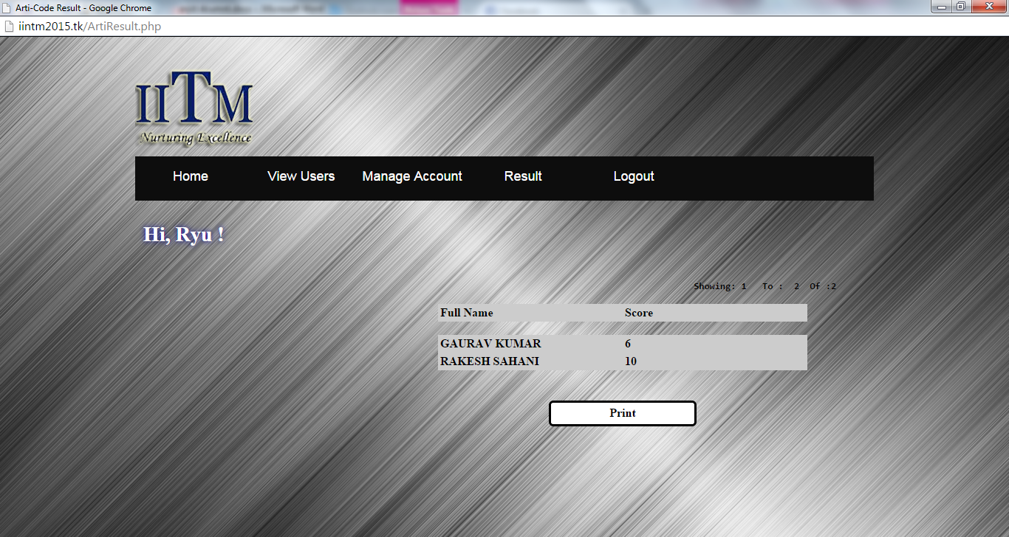

**Screenshot 4.21: Event Result Page**

* 1. **Logout.php**

<!DOCTYPE html PUBLIC "-//W3C//DTD XHTML 1.0 Transitional//EN" "http://www.w3.org/TR/xhtml1/DTD/xhtml1-transitional.dtd">

<html xmlns="http://www.w3.org/1999/xhtml">

<head>

<link href="CSS/Layout.css" rel="stylesheet" type="text/css"/>

<link href="CSS/Menu.css" rel="stylesheet" type="text/css"/>

<meta http-equiv="Content-Type" content="text/html; charset=utf-8" />

<title>Logout</title>

</head>

<body>

<div id="Holder">

<div id="Header"></div>

<div id="NavBar">

<nav>

<ul>

<li><a href="Register.php">Register</a></li>

<li><a href="Login.php">Login</a></li>

<li><a href="AdminLogin.php">Admin Login</a></li>

</ul>

</nav>

</div>

<div id="Content">

<div id="PageHeading">

<h1 id="Text2">

<?php

echo"SuccessFully Logout...!!!";

@session_destroy();

@session_unset();

header( "refresh:5;url=Login.php" );

?>

</h1>

</div>

<div id="ContentLeft">

<h2>&nbsp;</h2>

</div>

<div id="ContentRight"></div>

</div>

<div id="Footer"></div>

</div>

</body>

</html>



**Screenshot 4.22: Logout Page**

* 1. **InvalidLogin.php**

<?php

require_once('Connections/mysql.php');

@session_start();

if (!function_exists("GetSQLValueString")) {

function GetSQLValueString($theValue, $theType, $theDefinedValue = "", $theNotDefinedValue = "")

{

if (PHP_VERSION < 6) {

$theValue = get_magic_quotes_gpc() ? stripslashes($theValue) : $theValue;

}

$theValue = function_exists("mysql_real_escape_string") ? mysql_real_escape_string($theValue) : mysql_escape_string($theValue);

switch ($theType) {

case "text":

$theValue = ($theValue != "") ? "'" . $theValue . "'" : "NULL";

break;

case "long":

case "int":

$theValue = ($theValue != "") ? intval($theValue) : "NULL";

break;

case "double":

$theValue = ($theValue != "") ? doubleval($theValue) : "NULL";

break;

case "date":

$theValue = ($theValue != "") ? "'" . $theValue . "'" : "NULL";

break;

case "defined":

$theValue = ($theValue != "") ? $theDefinedValue : $theNotDefinedValue;

break;

}

return $theValue;

}

}

mysql_select_db($database_mysql, $mysql);

$query_Login = "SELECT * FROM register";

$Login = mysql_query($query_Login, $mysql) or die(mysql_error());

$row_Login = mysql_fetch_assoc($Login);

$totalRows_Login = mysql_num_rows($Login);

// *** Validate request to login to this site.

if (!isset($_SESSION)) {

session_start();

}

$loginFormAction = $_SERVER['PHP_SELF'];

if (isset($_GET['accesscheck'])) {

$_SESSION['PrevUrl'] = $_GET['accesscheck'];

}

if (isset($_POST['Username'])) {

$loginUsername=$_POST['Username'];

$password=$_POST['Password'];

$MM_fldUserAuthorization = "";

$MM_redirectLoginSuccess = "Account.php";

$MM_redirectLoginFailed = "InvalidLogin.php";

$MM_redirecttoReferrer = true;

mysql_select_db($database_mysql, $mysql);

$LoginRS__query=sprintf("SELECT Username, Password FROM register WHERE Username=%s AND Password=%s",

GetSQLValueString($loginUsername, "text"), GetSQLValueString($password, "text"));

$LoginRS = mysql_query($LoginRS__query, $mysql) or die(mysql_error());

$loginFoundUser = mysql_num_rows($LoginRS);

if ($loginFoundUser) {

$loginStrGroup = "";

if (PHP_VERSION >= 5.1) {session_regenerate_id(true);} else {session_regenerate_id();}

//declare two session variables and assign them

$_SESSION['MM_Username'] = $loginUsername;

$_SESSION['MM_UserGroup'] = $loginStrGroup;

if (isset($_SESSION['PrevUrl']) && true) {

$MM_redirectLoginSuccess = $_SESSION['PrevUrl'];

}

header("Location: " . $MM_redirectLoginSuccess );

}

else {

header("Location: ". $MM_redirectLoginFailed );

}

}

$query_AdminLogin = "SELECT * FROM `admin`";

$AdminLogin = mysql_query($query_AdminLogin, $mysql) or die(mysql_error());

$row_AdminLogin = mysql_fetch_assoc($AdminLogin);

$totalRows_AdminLogin = mysql_num_rows($AdminLogin);

?>

<!DOCTYPE html PUBLIC "-//W3C//DTD XHTML 1.0 Transitional//EN" "http://www.w3.org/TR/xhtml1/DTD/xhtml1-transitional.dtd">

<html xmlns="http://www.w3.org/1999/xhtml">

<head>

<link href="CSS/Layout.css" rel="stylesheet" type="text/css"/>

<link href="CSS/Menu.css" rel="stylesheet" type="text/css"/>

<link href="SpryAssets/SpryValidationTextField.css" rel="stylesheet" type="text/css" />

<meta http-equiv="Content-Type" content="text/html; charset=utf-8" />

<title>Invalid Login</title>

<script src="SpryAssets/SpryValidationTextField.js" type="text/javascript"></script>

</head>

<body>

<div id="Holder">

<div id="Header"></div>

<div id="NavBar">

<nav>

<ul>

<li><a href="Register.php">Register</a></li>

<li><a href="Login.php">Login</a></li>

<li><a href="AdminLogin.php">Admin Login</a></li>

</ul>

</nav>

</div>

<div id="Content">

<div id="PageHeading">

<h1 id="Text2"> Invalid Login, Please Try Again!</h1>

</div>

<div id="ContentLeft">

<h2 id="Text2">IINTM<br /><br />Organising Online Technical Fest 2K15 ..</h2>

</div>

<div id="ContentRight">

<form ACTION="<?php echo $loginFormAction; ?>" id="LoginForm" name="LoginForm" method="POST">

<table width="400" border="0" align="center">

<tr> </tr>

<tr> </tr>

</table>

<table width="456" border="0" align="center" id="Text">

<tr>

<td width="423"><h3>Username : <span id="sprytextfield1">

<label for="Username2"></label>

<input name="Username" type="text" class="StyleTextField" id="Username2" />

<span class="textfieldRequiredMsg">*</span></span></h3></td>

</tr>

<tr>

<td>&nbsp;</td>

</tr>

<tr>

<td><h3>Password : <span id="sprytextfield2">

<label for="Password"></label>

<input name="Password" type="Password" class="StyleTextField" id="Password" />

<span class="textfieldRequiredMsg">*</span></span></h3></td>

</tr>

<tr>

<td>&nbsp;</td>

</tr> <tr>

<td><input name="LoginButton" type="submit" class="StyleTextField" id="LoginButton" value="Login" /></td>

</tr> </table>

</form></div>

</div>

<div id="Footer"></div></div>

<script type="text/javascript">

var sprytextfield1 = new Spry.Widget.ValidationTextField("sprytextfield1");

var sprytextfield2 = new Spry.Widget.ValidationTextField("sprytextfield2");

</script>

</body>

</html>

<?php mysql_free_result($Login); ?>

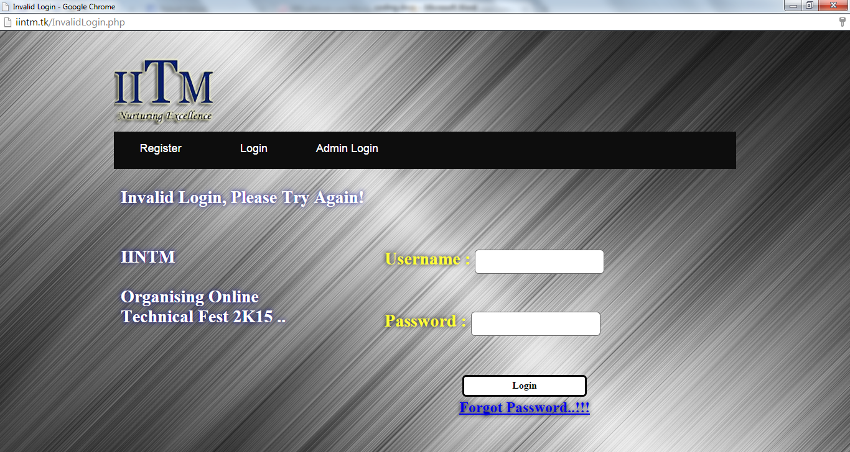

**Screenshot 4.23: Invalid Login Page**

* 1. **AdminInvalidLogin.php**

<?php @session_start();?>

<?php require_once('Connections/mysql.php'); ?>

<?php

if (!function_exists("GetSQLValueString")) {

function GetSQLValueString($theValue, $theType, $theDefinedValue = "", $theNotDefinedValue = "")

{

if (PHP_VERSION < 6) {

$theValue = get_magic_quotes_gpc() ? stripslashes($theValue) : $theValue;

}

$theValue = function_exists("mysql_real_escape_string") ? mysql_real_escape_string($theValue) : mysql_escape_string($theValue);

switch ($theType) {

case "text":

$theValue = ($theValue != "") ? "'" . $theValue . "'" : "NULL";

break;

case "long":

case "int":

$theValue = ($theValue != "") ? intval($theValue) : "NULL";

break;

case "double":

$theValue = ($theValue != "") ? doubleval($theValue) : "NULL";

break;

case "date":

$theValue = ($theValue != "") ? "'" . $theValue . "'" : "NULL";

break;

case "defined":

$theValue = ($theValue != "") ? $theDefinedValue : $theNotDefinedValue;

break;

}

return $theValue;

}

}

mysql_select_db($database_mysql, $mysql);

$query_AdminLogin = "SELECT * FROM `admin`";

$AdminLogin = mysql_query($query_AdminLogin, $mysql) or die(mysql_error());

$row_AdminLogin = mysql_fetch_assoc($AdminLogin);

$totalRows_AdminLogin = mysql_num_rows($AdminLogin);

?>

<?php

// *** Validate request to login to this site.

if (!isset($_SESSION)) {

session_start();

}

$loginFormAction = $_SERVER['PHP_SELF'];

if (isset($_GET['accesscheck'])) {

$_SESSION['PrevUrl'] = $_GET['accesscheck'];

}

if (isset($_POST['Username'])) {

$loginUsername=$_POST['Username'];

$password=$_POST['Password'];

$MM_fldUserAuthorization = "";

$MM_redirectLoginSuccess = "AdminManageHome.php";

$MM_redirectLoginFailed = "AdminInvalidLogin.php";

$MM_redirecttoReferrer = false;

mysql_select_db($database_mysql, $mysql);

$LoginRS__query=sprintf("SELECT Username, Password FROM `admin` WHERE Username=%s AND Password=%s",

GetSQLValueString($loginUsername, "text"), GetSQLValueString($password, "text"));

$LoginRS = mysql_query($LoginRS__query, $mysql) or die(mysql_error());

$loginFoundUser = mysql_num_rows($LoginRS);

if ($loginFoundUser) {

$loginStrGroup = "";

if (PHP_VERSION >= 5.1) {session_regenerate_id(true);} else {session_regenerate_id();}

//declare two session variables and assign them

$_SESSION['MM_Username'] = $loginUsername;

$_SESSION['MM_UserGroup'] = $loginStrGroup;

if (isset($_SESSION['PrevUrl']) && false) {

$MM_redirectLoginSuccess = $_SESSION['PrevUrl'];

}

header("Location: " . $MM_redirectLoginSuccess );

}

else {

header("Location: ". $MM_redirectLoginFailed );

}

}

?>

<?php

$query_Login = "SELECT * FROM register";

$Login = mysql_query($query_Login, $mysql) or die(mysql_error());

$row_Login = mysql_fetch_assoc($Login);

$totalRows_Login = mysql_num_rows($Login);

?>

<!DOCTYPE html PUBLIC "-//W3C//DTD XHTML 1.0 Transitional//EN" "http://www.w3.org/TR/xhtml1/DTD/xhtml1-transitional.dtd">

<html xmlns="http://www.w3.org/1999/xhtml">

<head>

<link href="CSS/Layout.css" rel="stylesheet" type="text/css"/>

<link href="CSS/Menu.css" rel="stylesheet" type="text/css"/>

<link href="SpryAssets/SpryValidationTextField.css" rel="stylesheet" type="text/css" />

<meta http-equiv="Content-Type" content="text/html; charset=utf-8" />

<title>Admin Invalid Login</title>

<script src="SpryAssets/SpryValidationTextField.js" type="text/javascript"></script>

</head>

<body>

<div id="Holder">

<div id="Header"></div>

<div id="NavBar">

<nav>

<ul>

<li><a href="Register.php">Register</a></li>

<li><a href="Login.php">Login</a></li>

<li><a href="AdminLogin.php">Admin Login</a></li>

</ul>

</nav>

</div>

<div id="Content">

<div id="PageHeading">

<h1 id="Text2"> Admin Invalid Login, Please Try Again!</h1>

</div>

<div id="ContentLeft">

<h2 id="Text2">IINTM<br /><br />Organising Online Technical Fest 2K15 ..</h2>

</div>

<div id="ContentRight">

<form ACTION="<?php echo $loginFormAction; ?>" id="LoginForm" name="LoginForm" method="POST">

<table width="400" border="0" align="center">

<tr> </tr>

<tr> </tr>

</table>

<table width="456" border="0" align="center" id="Text">

<tr>

<td width="423"><h3>Username : <span id="sprytextfield1">

<label for="Username2"></label>

<input name="Username" type="text" class="StyleTextField" id="Username2" />

<span class="textfieldRequiredMsg">*</span></span></h3></td>

</tr>

<tr>

<td>&nbsp;</td>

</tr>

<tr>

<td><h3>Password : <span id="sprytextfield2">

<label for="Password"></label>

<input name="Password" type="Password" class="StyleTextField" id="Password" />

<span class="textfieldRequiredMsg">*</span></span></h3></td>

</tr>

<tr> <td>&nbsp;</td> </tr>

<tr>

<td><input name="LoginButton" type="submit" class="StyleTextField" id="LoginButton" value="Login" /></td>

</tr>

</table>

</form>

</div></div>

<div id="Footer"></div>

<script type="text/javascript">

var sprytextfield1 = new Spry.Widget.ValidationTextField("sprytextfield1");

var sprytextfield2 = new Spry.Widget.ValidationTextField("sprytextfield2");

</script>

</body>

</html>

<?php mysql_free_result($AdminLogin); ?>

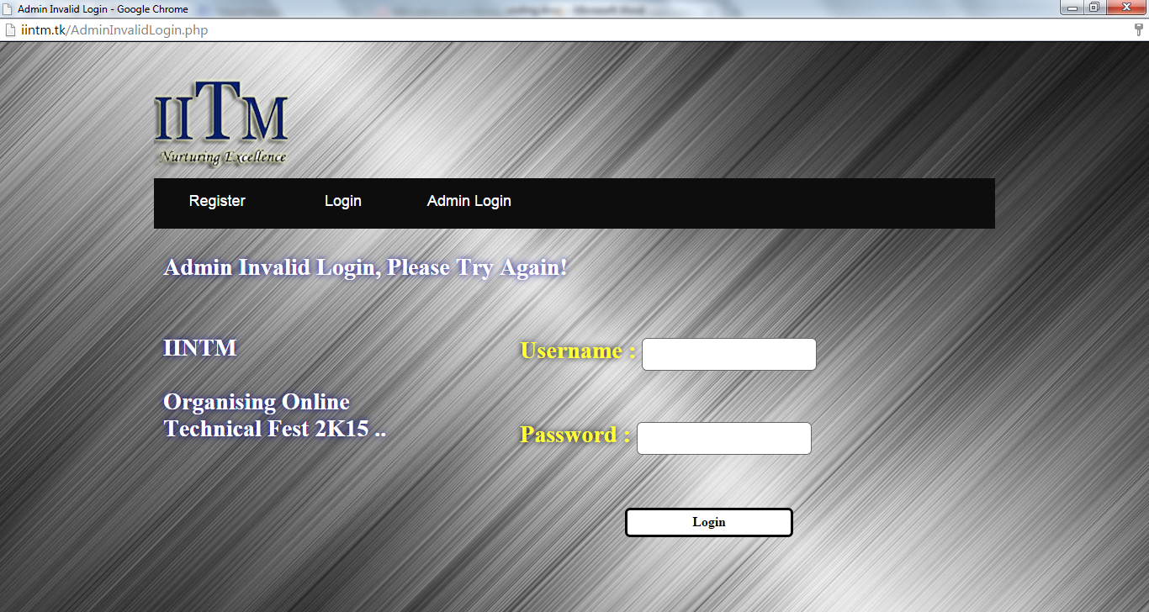

**Screenshot 4.24: Admin Invalid Login Page**

* 1. **ForgotPassword.php**

<!DOCTYPE html PUBLIC "-//W3C//DTD XHTML 1.0 Transitional//EN" "http://www.w3.org/TR/xhtml1/DTD/xhtml1-transitional.dtd">

<html xmlns="http://www.w3.org/1999/xhtml">

<head>

<link href="CSS/Layout.css" rel="stylesheet" type="text/css"/>

<link href="CSS/Menu.css" rel="stylesheet" type="text/css"/>

<link href="SpryAssets/SpryValidationTextField.css" rel="stylesheet" type="text/css" />

<meta http-equiv="Content-Type" content="text/html; charset=utf-8" />

<title>Forgot Password</title>

<script src="SpryAssets/SpryValidationTextField.js" type="text/javascript"></script>

</head>

<body>

<div id="Holder">

<div id="Header"></div>

<div id="NavBar">

<nav>

<ul>

<li><a href="Register.php">Register</a></li>

<li><a href="Login.php">Login</a></li>

<li><a href="AdminLogin.php">Admin Login</a></li>

</ul>

</nav>

</div>

<div id="Content">

<div id="PageHeading">

<h1>&nbsp;</h1>

</div>

<div id="ContentLeft">

<h2 id="Text2">Enter Valid Email Address </h2>

</div>

<div id="ContentRight">

<form id="EPForm" name="EPForm" method="post" action="EmailPassword.php">

<div align="center">

<table width="400" border="0" align="center">

<tr>

<td><h2><span id="sprytextfield1">

<label for="Email"></label>

<input name="Email" type="text" class="StyleTextField" id="Email" />

<span class="textfieldRequiredMsg">A value is required.</span></span><br />

<br />

<input name="EMPWButton" type="submit" class="StyleTextField" id="EMPWButton" value="Email Password" />

<br />

</h2></td>

</tr>

</table>

</div>

<label for="Email"></label>

<div id="h6">

<div > </div>

</div>

</span>

<div align="left"></div>

</form>

</div>

</div>

<div id="Footer"></div>

</div>

<script type="text/javascript">

var sprytextfield1 = new Spry.Widget.ValidationTextField("sprytextfield1");

</script>

</body>

</html>

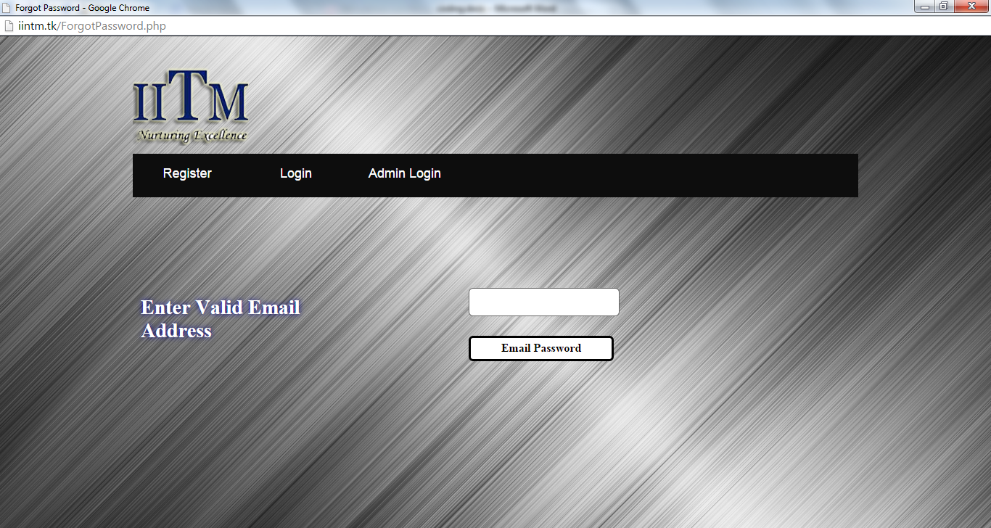

**Screenshot 4.25: Forgot Password Page**

* 1. **EmailPassword.php**

<!DOCTYPE html PUBLIC "-//W3C//DTD XHTML 1.0 Transitional//EN" "http://www.w3.org/TR/xhtml1/DTD/xhtml1-transitional.dtd">

<html xmlns="http://www.w3.org/1999/xhtml">

<head>

<link href="CSS/Layout.css" rel="stylesheet" type="text/css"/>

<link href="CSS/Menu.css" rel="stylesheet" type="text/css"/>

<link href="SpryAssets/SpryValidationTextField.css" rel="stylesheet" type="text/css" />

<meta http-equiv="Content-Type" content="text/html; charset=utf-8" />

<title>Forgot</title>

</head>

<body>

<div id="Holder">

<div id="Header"></div>

<div id="Content">

<div id="PageHeading">

<h1 align="center">

<?php

@session_start();

$_SESSION['EMPW'] = $_POST['Email'];

require_once('Connections/mysql.php');

if (!function_exists("GetSQLValueString")) {

function GetSQLValueString($theValue, $theType, $theDefinedValue = "", $theNotDefinedValue = "")

{

if (PHP_VERSION < 6) {

$theValue = get_magic_quotes_gpc() ? stripslashes($theValue) : $theValue;

}

$theValue = function_exists("mysql_real_escape_string") ? mysql_real_escape_string($theValue) : mysql_escape_string($theValue);

switch ($theType) {

case "text":

$theValue = ($theValue != "") ? "'" . $theValue . "'" : "NULL";

break;

case "long":

case "int":

$theValue = ($theValue != "") ? intval($theValue) : "NULL";

break;

case "double":

$theValue = ($theValue != "") ? doubleval($theValue) : "NULL";

break;

case "date":

$theValue = ($theValue != "") ? "'" . $theValue . "'" : "NULL";

break;

case "defined":

$theValue = ($theValue != "") ? $theDefinedValue : $theNotDefinedValue;

break;

}

return $theValue;

}

}

$colname_EmailPasswordRecovery = "-1";

if (isset($_SESSION['EMPW'])) {

$colname_EmailPasswordRecovery = $_SESSION['EMPW'];

}

mysql_select_db($database_mysql, $mysql);

$query_EmailPasswordRecovery = sprintf("SELECT * FROM register WHERE Email = %s", GetSQLValueString($colname_EmailPasswordRecovery, "text"));

$EmailPasswordRecovery = mysql_query($query_EmailPasswordRecovery, $mysql) or die(mysql_error());

$row_EmailPasswordRecovery = mysql_fetch_assoc($EmailPasswordRecovery);

$totalRows_EmailPasswordRecovery = mysql_num_rows($EmailPasswordRecovery);

mysql_free_result($EmailPasswordRecovery);

?>

<h1 id="Text2">

<?php

if($totalRows_EmailPasswordRecovery>0)

{

$from = "noreply@iintm.tk";

$email =$_POST['Email'];

$subject = "Your Email Password";

$message = "Here is Your Password :".$row_EmailPasswordRecovery['Password'];

mail($email,$subject,$message,"From:".$from);

}

if($totalRows_EmailPasswordRecovery>0)

{

echo"Please Check Your Email ID,Password SuccessFully Sent ......!!!";

}

else

{

echo"Failed - Please Check Your Email ID......!!!";

}

@session_destroy();

@session_unset();

?>

</h1>

</div>

</div>

<div id="Footer"></div>

</div>

</body>

</html>



**Screenshot 4.26: Password Successfully Sent Page**

* 1. **Database Design**

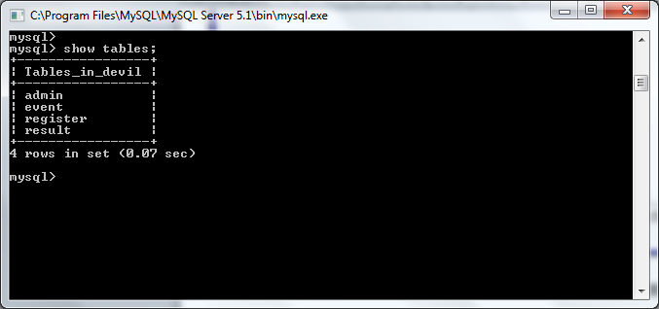

**Screenshot 4.27: Database Tables**

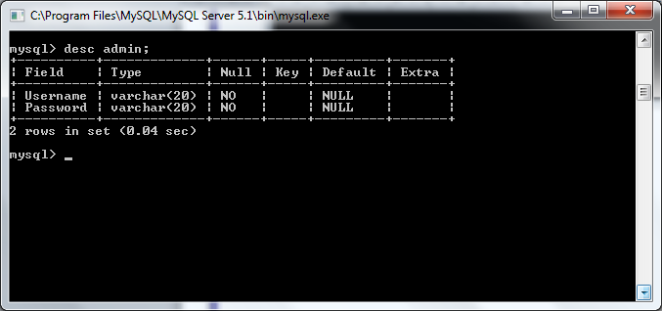

**Screenshot 4.28: Admin Table**

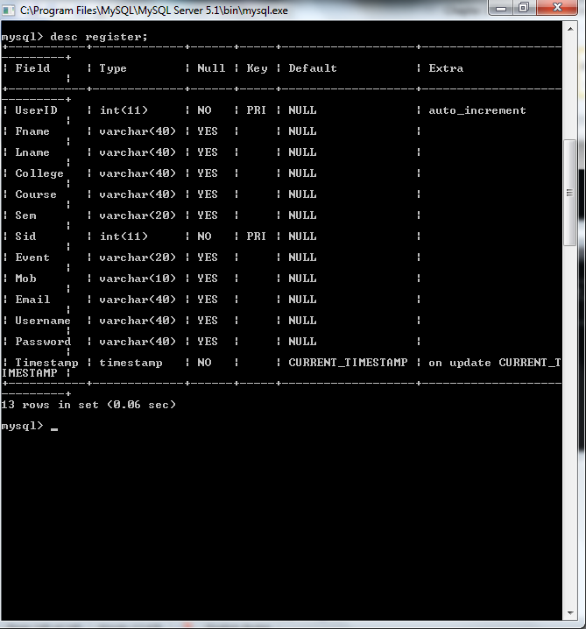

**Screenshot 4.29: Register Table**

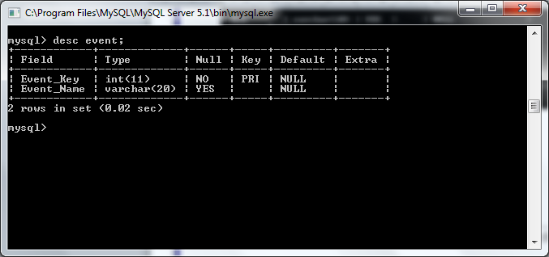

**Screenshot 4.30: Event Table**

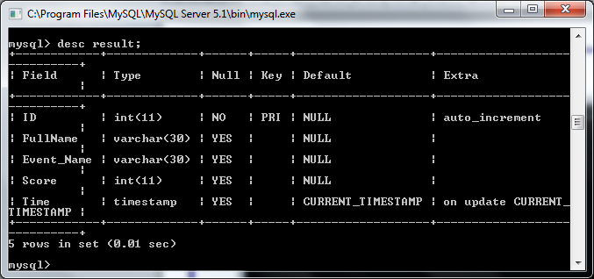

**Screenshot 4.31: Result Table**

**Chapter 5: System Testing**

**Chapter – 5**

**System Testing**

**5.1 Introduction:**

**System testing** of software or hardware is testing conducted on a complete, integrated system to evaluate the system's compliance with its specified [requirements](http://en.wikipedia.org/wiki/Requirements). System testing falls within the scope of [black box testing](http://en.wikipedia.org/wiki/Black_box_testing), and as such, should require no knowledge of the inner design of the code or logic.

As a rule, system testing takes, as its input, all of the "integrated" software components that have passed [integration testing](http://en.wikipedia.org/wiki/Integration_testing) and also the software system itself integrated with any applicable hardware system(s). The purpose of integration testing is to detect any inconsistencies between the software units that are integrated together (called *assemblages*) or between any of the *assemblages* and the hardware. System testing is a more limited type of testing; it seeks to detect defects both within the "inter-assemblages" and also within the system as a whole.

**Types of system testing :**

**5.1.1 Unit testing**

**Unit testing** is a [software testing](http://en.wikipedia.org/wiki/Software_testing) method by which individual units of [source code](http://en.wikipedia.org/wiki/Source_code), sets of one or more computer program modules together with associated control data, usage procedures, and operating procedures are tested to determine if they are fit for use. Intuitively, one can view a unit as the smallest testable part of an application.

**5.1.2Integration testing**

**Integration testing** (sometimes called integration and testing, abbreviated I&T) is the phase in [software testing](http://en.wikipedia.org/wiki/Software_testing) in which individual software modules are combined and tested as a group. It occurs after [unit testing](http://en.wikipedia.org/wiki/Unit_testing) and before [validation testing](http://en.wikipedia.org/wiki/Verification_and_validation_%28software%29). Integration testing takes as its input [modules](http://en.wikipedia.org/wiki/Module_%28programming%29) that have been [unit tested](http://en.wikipedia.org/wiki/Unit_testing), groups them in larger aggregates, applies tests defined in an integration [test plan](http://en.wikipedia.org/wiki/Test_plan) to those aggregates, and delivers as its output the integrated system ready for [system testing](http://en.wikipedia.org/wiki/System_testing).

## 5.1.3 Automation testing

In [software testing](http://en.wikipedia.org/wiki/Software_testing), test automation is the use of special [software](http://en.wikipedia.org/wiki/Software) (separate from the software being tested) to control the execution of tests and the comparison of actual outcomes with predicted outcomes. Test automation can automate some repetitive but necessary tasks in a formalized testing process already in place, or add additional testing that would be difficult to perform manually.

## 5.1.4 Regression testing

## Regression testing is a type of [software testing](http://en.wikipedia.org/wiki/Software_testing) that seeks to uncover new [software bugs](http://en.wikipedia.org/wiki/Software_bug), or [*regressions*](http://en.wikipedia.org/wiki/Software_regression), in existing [functional](http://en.wikipedia.org/wiki/Functional_testing) and [non-functional](http://en.wikipedia.org/wiki/Non-functional_testing) areas of a system after changes such as enhancements, [patches](http://en.wikipedia.org/wiki/Patch_%28computing%29) or [configuration](http://en.wikipedia.org/wiki/Configuration_file) changes, have been made to them.

The intent of regression testing is to ensure that changes such as those mentioned above have not introduced new faults. One of the main reasons for regression testing is to determine whether a change in one part of the software affects other parts of the software.

**Test case generation**

To generate a set of test cases, test designers attempt to cover all the functionality of the system and fully exercise the GUI itself.

**Test case**

|  |  |  |  |  |
| --- | --- | --- | --- | --- |
| **Test case Id 1** | | | | |
| **Login form** | | | | |
|  | **Input** | | **Output** | |
| Field name | Actual | Expected | Actual | Expected |
| Userid  Password | devil  only1ryu | devilmind  only1ryu | Error in login <invalid username> | Successfully logged in |
| Userid  password | devilmind  onlyryu | devilmind  only1 | Error in login <invalid password> | Successfully logged in |
| Userid  Password | devilmind  only1ryu | devilmind  only1ryu | Successfully logged in | Successfully logged in |

Table 5.1

|  |  |  |  |  |
| --- | --- | --- | --- | --- |
| **Test case Id 2** | | | | |
| **Student Registration** | | | | |
|  | **Input** | | **Output** | |
| Field name | Actual | Expected | Actual | Expected |
| Userid | Null | 101 | Error <userid cannot be null> | Successfully Registered |
| Userid | 101 | 101 | Successfully Registered | Successfully Registered |
| First Name | Null | Enter by user | Error <Fname cannot be null> | Successfully Registered |
| First Name | Gaurav | Gaurav | Successfully Registered | Successfully Registered |
| Last Name | Null | Enter by user | Error <Lname cannot be null> | Successfully Registered |
| Last Name | Kumar | Kumar | Successfully Registered | Successfully Registered |
| College | Null | Enter by user | Error <College cannot be null> | Successfully Registered |
| College | COMM_IT | COMM_IT | Successfully Registered | Successfully Registered |
| Course | Null | Enter by user | Error <Course cannot be null> | Successfully Registered |
| Course | B.C.A | B.C.A | Successfully Registered | Successfully Registered |
| Semester | null | Enter by user | Error <Semester cannot be null> | Successfully Registered |
| Semester | 6 | 6 | Successfully Registered | Successfully Registered |
| Student_id | null | Enter by user | Error <s_id cannot be null> | Successfully Registered |
| Student_id | 01812002012 | 01812002012 | Successfully Registered | Successfully Registered |
| Event | null | Enter by user | Error <Event cannot be null> | Successfully Registered |
| Event | 651993 | 651993 | Successfully Registered | Successfully Registered |
| Mobile | null | Enter by user | Error <Mobile cannot be null> | Successfully Registered |
| Mobile | 9971962899 | 9971962899 | Successfully Registered | Successfully Registered |
| User Name | null | Enter by user | Error <username cannot be null> | Successfully Registered |
| User Name | gaurav | Gaurav | Successfully Registered | Successfully Registered |
| Email | null | Enter by user | Error <Email cannot be null> | Successfully Registered |
| Email | Gauravkumar  5828@gmail.com | Gauravkumar  [5828@gmail.com](mailto:5828@gmail.com) | Successfully Registered | Successfully Registered |
| Password | null | Enter by user | Error <Password cannot be null> | Successfully Registered |
| Password | ********* | ******** | Successfully Registered | Successfully Registered |

Table 5.2

**Chapter 6: Future scope and Conclusion**

**Chapter – 6**

**Future scope and Conclusion**

* 1. **Future scope**

Online Technical Fest aims at conducting and managing fest events online to reduce the efforts and make the process faster. This helps to inform about the events and their details to a huge number of viewers. This helps the students to register themselves anywhere and anytime.

* 1. **Scope of Improvement**

There is no scope of improvement because everything has shown in this project.

* 1. **Conclusion**

The entire modules are connected to respective tables and when admin use any module then all the functions are performed directly on the tables. For making project more accurate some test case are done and all the results from those test cases are included in documentation. At last we fulfil our goal by making software which is less prone to errors and tried to make it user friendly to the extent we could.Every Student can use this application which are interested in technical festival events and get notification and update related to college’s technical festival Event. The students and college interaction for technical event scheduling will get easier.

**Bibliography**

**Books:**

1. Software engineering (Third edition K.K.Aggarwal and Yogesh Singh

3rd edition )

1. Software Testing(Paul C. Jorgensen 6th edition )
2. DBMS(Ramez Elmasri and Shamkant B.Navathe 5th edition )
3. Web technology

**Search Engine:**

1. Google
2. Yahoo

**Sites we referred:**

1. www.wikipedia.org
2. www.w3schools.com/html